**VISVESVARAYA TECHNOLOGICAL UNIVERSITY**

**“JnanaSangama”, Belgaum -590014, Karnataka.**



**LAB REPORT**

**on**

**OBJECT ORIENTED MODELLING AND DESIGN**

***Submitted by***

**AFIFAH KHAN (1BM20CS195)**

***in partial fulfillment for the award of the degree of***

**BACHELOR OF ENGINEERING**

***in***

**COMPUTER SCIENCE AND ENGINEERING**



**B.M.S. COLLEGE OF ENGINEERING**

**(Autonomous Institution under VTU)**

**BENGALURU-560019**

**March-2023 to July-2023**

**B. M. S. College of Engineering,**

**Bull Temple Road, Bangalore 560019**

(Affiliated To Visvesvaraya Technological University, Belgaum)

**Department of Computer Science and Engineering**



**CERTIFICATE**

This is to certify that the Lab work entitled “**OBJECT ORIENTED MODELLING AND DESIGN**” carried out by **AFIFAH KHAN (1BM20CS195),** who is bonafide student of **B. M. S. College of Engineering.** It is in partial fulfillment for the award of **Bachelor of Engineering in Computer Science and Engineering** of the Visvesvaraya Technological University, Belgaum during the year 2023. The Lab report has been approved as it satisfies the academic requirements in respect of a **Object Oriented Modelling And Design - (20CS6PCOMD)** work prescribed for the said degree.

Dr. Seema Patil            **Dr. Jyothi S Nayak**

Assistant Professor Professor and Head

Department of CSE Department of CSE

BMSCE, Bengaluru BMSCE, Bengaluru

**Index Sheet**

|  |  |  |
| --- | --- | --- |
| **Sl. No.** | **Experiment Title** | **Page No.** |
| **1** | **Hotel Management System** | **4-13** |
| **2** | **Credit Card Processing** | **14-21** |
| **3** | **Library Management System** | **22-31** |
| **4** | **Stock Maintenance System** | **32-39** |
| **5** | **Passport Automation System** | **40-48** |
| **6** | **Railway Reservation System** | **49-58** |
| **7** | **Online Shopping System** | **59-68** |
|  |  |  |
|  |  |  |
|  |  |  |
|  |  |  |
|  |  |  |
|  |  |  |
|  |  |  |
|  |  |  |

**Course Outcome**

|  |  |
| --- | --- |
| **CO1** | Ability to apply the knowledge of class, State & Interaction Modelling using Unified Modeling Language to solve a given problem. |
| **CO2** | Ability to analyze a System for a given requirement using Unified Modeling language. |
| **CO3** | Ability to design a given system using high level strategy. CO4 Ability to conduct practical experiments to solve a given problem using Unified Modeling language. |

**Hotel Management System**

# **Problem Statement:**

To design a new and improved Library Management System for ABC College, it is necessary to address the shortcomings of the current system. The current system's inefficiency and lack of user-friendliness have resulted in manual management of collections and patron records, which is time-consuming and error-prone. The new system must improve the efficiency of library operations by automating the collection and patron record management, providing easy access to information, and streamlining administrative tasks. Additionally, it should provide better support for managing the collections, including advanced search capabilities and an intuitive user interface for browsing and reserving items. Ultimately, the new system must enhance the user experience for students and staff, making it easy to use and providing access to a vast collection of resources.

**Software Requirement Specification(SRS)**

**1 Introduction:**

**1.1 Purpose of this Document:**

The purpose of this SRS is to define the requirements for the development of a Library Management System. It provides a detailed description of the system and its features, along with the scope, constraints, and non-functional requirements.

**1.2 Scope of this Document:**

This document outlines the requirements for the Library Management System, which is a software application designed to manage the day-to-day operations of a library. The system is intended to provide a user-friendly interface for library staff to manage the library's resources, such as books, journals, and other materials, as well as to manage patron accounts and circulation of materials. The system will also include reporting capabilities to provide data analysis and decision support.

**1.3 Overview:**

The Library Management System is a web-based application that allows librarians to manage their library's resources and patrons. The system will include modules for managing books, journals, and other materials, as well as for managing patron accounts and circulation of materials. The system will be designed to be user-friendly and intuitive, with an emphasis on ease-of-use and efficiency.

**2 General Description:**

**2.1 Objective:**

The objective of the Library Management System is to provide a comprehensive tool for librarians to manage the library's resources and patrons. The system will be designed to streamline library operations and improve the overall efficiency of the library.

**2.2 User Characteristics:**

The system is intended for use by library staff, including librarians, library assistants, and other personnel. Users will be expected to have basic computer skills and knowledge of library operations.

**2.3 Features:**

The Library Management System will include the following features:

* Cataloging and classification of library materials
* Circulation of materials, including check-in/check-out and renewal
* Patron management, including registration, tracking, and notification
* Reporting and analysis of library data
* Integration with external databases and systems

**2.4 Benefits:**

The Library Management System will provide numerous benefits to the library, including:

* Improved efficiency and productivity of library staff
* Improved accuracy and reliability of library data
* Increased availability of library resources to patrons
* Enhanced patron experience and satisfaction

**2.5 User Community:**

The Library Management System is designed for use by libraries of all sizes and types, including public, academic, and special libraries. The system is intended to be scalable and flexible, allowing for customization to meet the unique needs of each library.

**3 Functional Requirements:**

**3.1 Cataloging and Classification:**

The system shall provide the ability to catalog and classify library materials, including books, journals, and other materials. Cataloging shall include data entry, editing, and deletion of bibliographic records.

**3.2 Circulation:**

The system shall provide the ability to circulate library materials, including check-in/check-out and renewal of materials. The system shall also provide notification of overdue materials and hold requests.

**3.3 Patron Management:**

The system shall provide the ability to manage patron accounts, including registration, tracking, and notification of account activity.

**3.4 Reporting and Analysis:**

The system shall provide the ability to generate reports and perform data analysis on library data, including circulation, cataloging, and patron activity.

**3.5 Integration:**

The system shall provide the ability to integrate with external databases and systems, including interlibrary loan systems and online databases.

**4 Interface Requirements:**

**4.1 User Interface:**

The user interface shall be designed to be user-friendly and intuitive, with an emphasis on ease-of-use and efficiency. The interface shall be web-based and accessible from any internet-connected device.

**4.2 System Interfaces:**

The system shall communicate with external databases and systems through APIs or other standard communication protocols.

**5 Performance Requirements:**

**5.1 Response Time:**

The system shall provide a response time of no more than 3 seconds for any user action.

**5.2 Capacity:**

The system shall be designed to handle a minimum of 500 simultaneous users.

**5.3 Data Storage:**

The system shall be able to handle a minimum of 100,000 bibliographic records and 50,000 patron records.

**5.4 Reliability:**

The system shall have a minimum uptime of 99.9% and shall be able to recover from any system failure within 15 minutes.

**6 Design Constraints:**

**6.1 Hardware:**

The system shall be designed to run on standard hardware configurations, including servers, workstations, and mobile devices.

**6.2 Software:**

The system shall be designed to run on standard software platforms, including web browsers and operating systems.

**6.3 Security:**

The system shall be designed to adhere to industry-standard security practices, including encryption of data and user authentication.

**7 Non-Functional Attributes:**

**7.1 Portability:**

The system shall be designed to be easily portable to different hardware and software platforms.

**7.2 Reusability:**

The system shall be designed to be easily reusable in other library settings.

**7.3 Application Compatibility:**

The system shall be designed to be compatible with other library applications and systems.

**7.4 Data Integrity:**

The system shall ensure the integrity and accuracy of all library data.

**7.5 Scalability:**

The system shall be designed to be scalable to meet the needs of libraries of all sizes.

**8 Preliminary Schedule and Budget:**

**8.1 Schedule:**

The development of the Library Management System is expected to take 12 months from the start of development to the final release.

**8.2 Budget:**

The estimated cost of development of the Library Management System is $150,000, including all hardware, software, and personnel costs.

**Class Diagram**

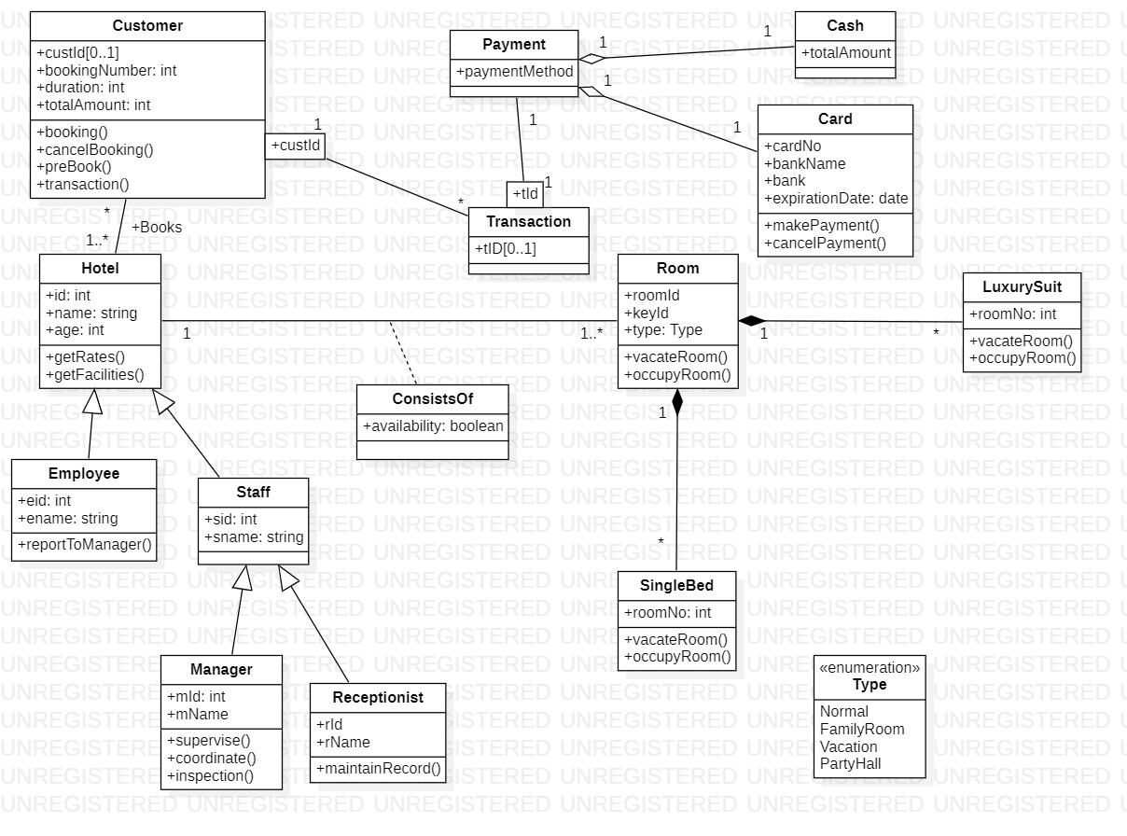

**Figure 1.1**

**State Diagram**

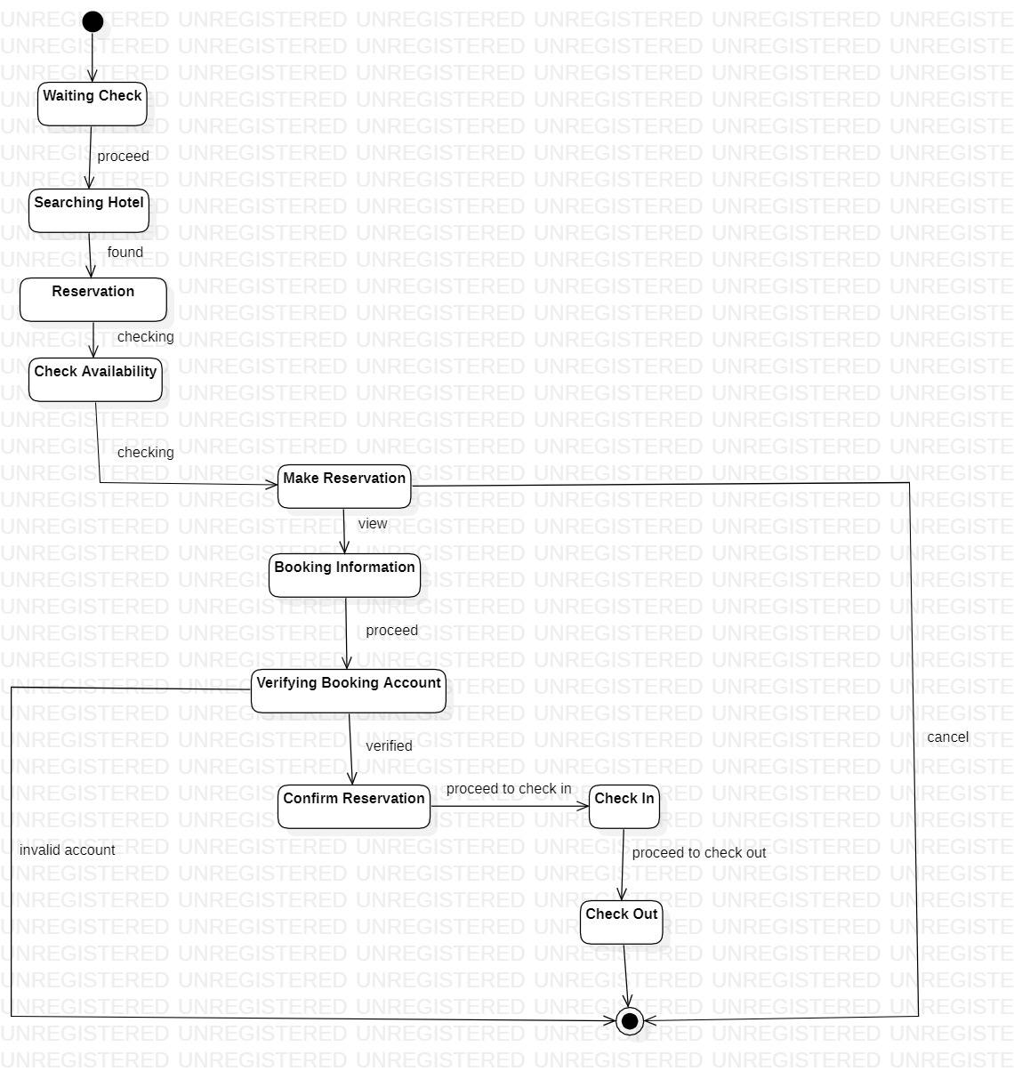

**Fig 1.2**

**Use Case Diagram**

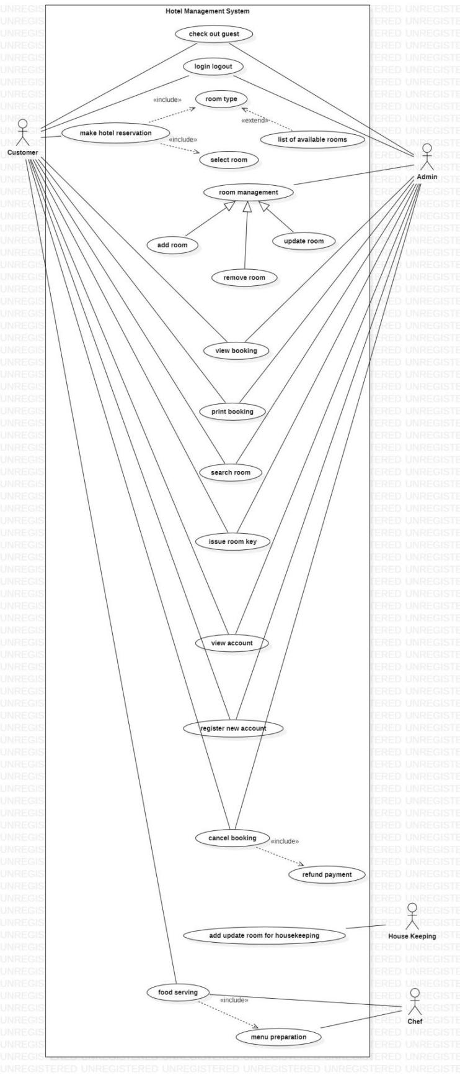

**Fig 1.3**

**Sequence Diagram**

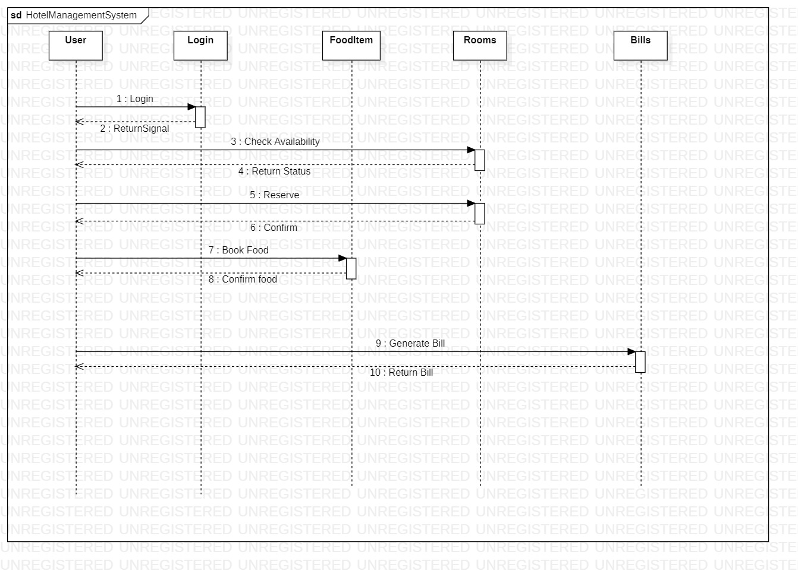

**Fig 1.4**

**Activity Diagram**

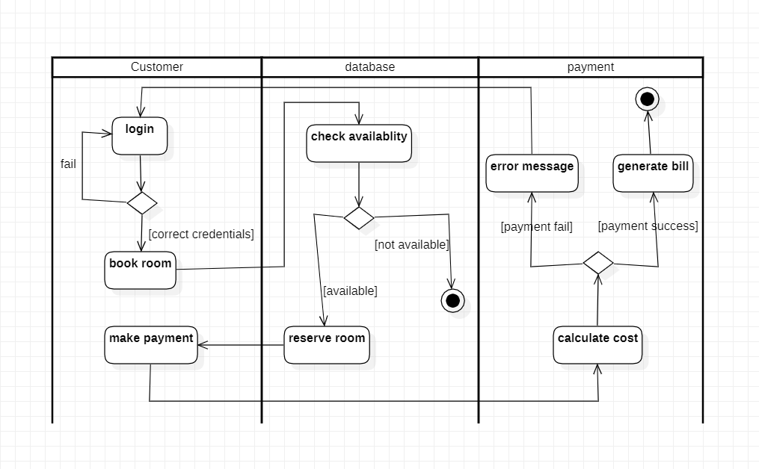

**Fig 1.5**

**Credit Card Processing**

# **Problem Statement:**

To design a credit card processing system that overcomes the challenges faced by merchants, customers, and banks during credit card transactions. The current systems often lack transparency, security, and reliability, leading to low trust and confidence among stakeholders. This results in lost sales for merchants, inconvenience for customers, and financial losses for banks due to chargebacks and disputes. The proposed system should be fast, secure, and reliable, ensuring seamless and error-free processing of credit card transactions for all parties involved. It should also minimize the risk of fraud and disputes by incorporating advanced security measures and real-time tracking of transactions. Moreover, the system should comply with relevant industry standards and regulations and be scalable and adaptable to meet the changing needs of the market. By addressing these issues, the new credit card processing system will improve the user experience, reduce financial losses, and enhance trust and confidence in the credit card processing industry.

# **Software Requirement Specification(SRS)**

**1 Introduction:**

**1.1 Purpose of this Document:**

The purpose of this document is to provide a detailed description of the requirements for the development of a Credit Card Processing System. This document outlines the functional and non-functional requirements of the system and serves as a guide for the development team.

**1.2 Scope of this Document:**

The document covers the functional and non-functional requirements of the Credit Card Processing System. It also includes design constraints, interface requirements, performance requirements, non-functional attributes, and a preliminary schedule and budget.

**1.3 Overview:**

The Credit Card Processing System is a software application designed to enable businesses to accept credit card payments from their customers. The system provides a secure, fast, and reliable way to process credit card payments, reducing the risk of fraud and increasing customer satisfaction.

**2 General Description:**

The Credit Card Processing System should meet the following general requirements:

* The system should enable businesses to accept credit card payments from their customers securely and efficiently.
* The system should provide an easy-to-use interface for business owners to manage their credit card payments and transactions.
* The system should be flexible and customizable to accommodate different business needs and requirements.

**3 Functional Requirements:**

The Credit Card Processing System should meet the following functional requirements:

* The system should allow businesses to enter credit card information manually or through a card reader.
* The system should verify the credit card information and check for any fraud or suspicious activity.
* The system should process the credit card payment securely and efficiently.
* The system should generate reports and receipts for each transaction.
* The system should allow businesses to manage refunds and chargebacks.

**4 Interface Requirements:**

The Credit Card Processing System should provide the following interfaces to enable efficient communication between the system and its users:

* A user-friendly interface for business owners to manage their credit card payments and transactions.
* An interface for customers to enter their credit card information securely.
* An interface for the system to communicate with other payment gateways and card issuers.

**5 Performance Requirements:**

The Credit Card Processing System should meet the following performance requirements:

* The system should be able to handle a high volume of credit card payments and transactions.
* The system should have a response time of less than 2 seconds for all user interactions.
* The system should be able to handle multiple user sessions simultaneously without any downtime.

**6 Design Constraints:**

The following design constraints should be considered during the development of the Credit Card Processing System:

* The system should be developed using a secure architecture that can protect credit card data and transactions from unauthorized access.
* The system should be compatible with commonly used hardware and software platforms.
* The system should be designed to minimize maintenance requirements and ensure ease of upgrades.

**7 Non-Functional Attributes:**

The Credit Card Processing System should meet the following non-functional attributes:

* Security: The system should be secure and protect credit card data and transactions from unauthorized access.
* Portability: The system should be portable and able to run on different hardware and software platforms.
* Reliability: The system should be reliable and minimize downtime or errors.
* Reusability: The system should be designed to facilitate the reuse of components and modules in future projects.
* Application Compatibility: The system should be compatible with other applications used in the payment processing industry.
* Data Integrity: The system should ensure data integrity and accuracy of information.
* Scalability Capacity: The system should be designed to accommodate future growth and scale easily.

**8 Preliminary Schedule and Budget:**

The development of the Credit Card Processing System is estimated to take eight months, and the budget for the project is $150,000. The development team will work in phases, with each phase having specific deliverables and milestones. The project manager will oversee the project and ensure that the development team adheres to the timeline and budget. Regular progress reports will be provided to stakeholders to keep them informed of the project's status.

**Class Diagram**

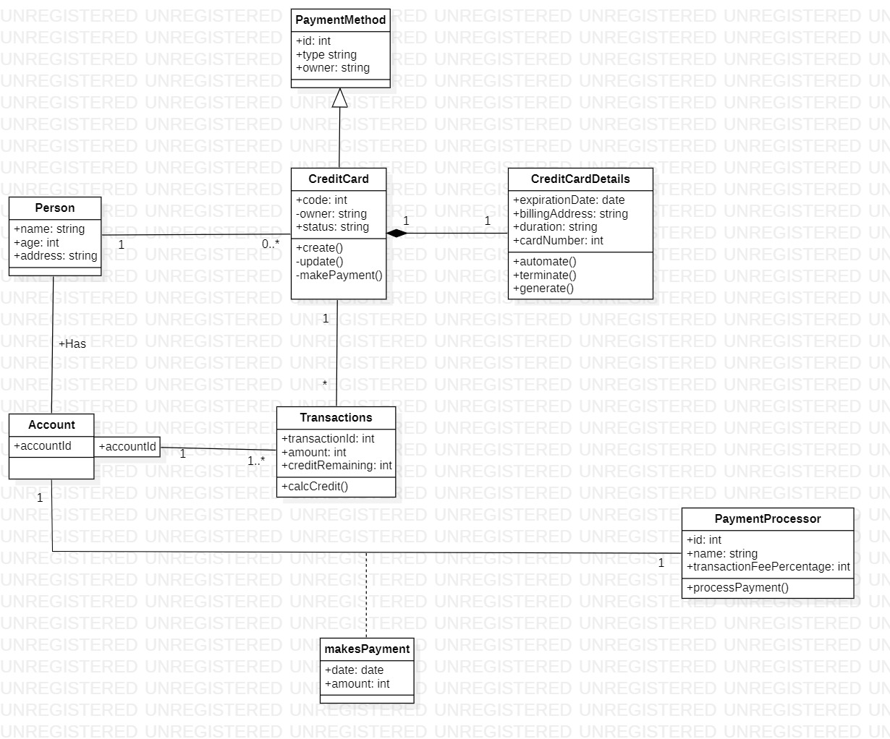

**Fig 2.1**

**State Diagram**

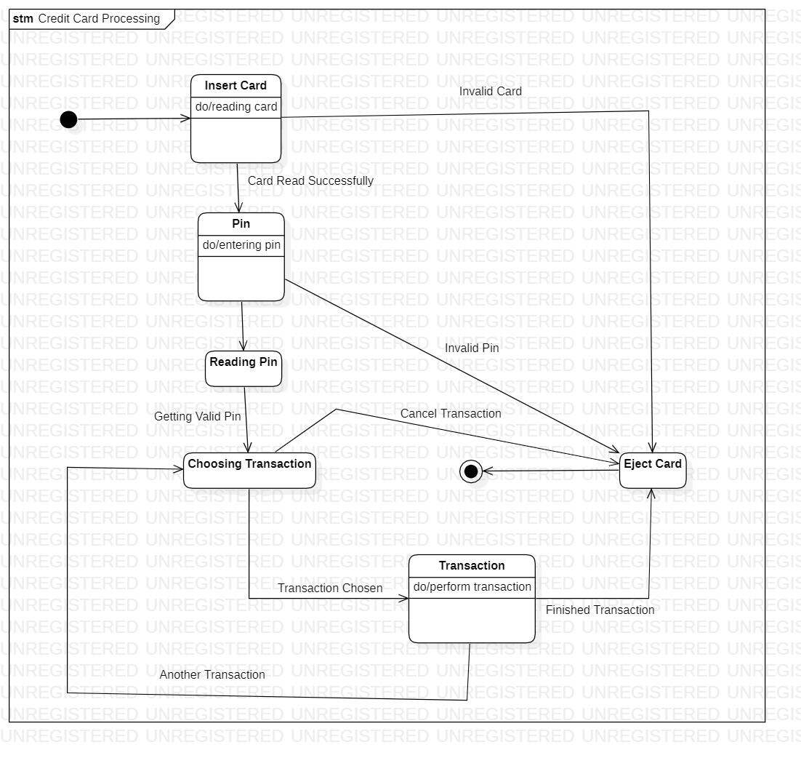

**Fig 2.2**

**Use Case Diagram**

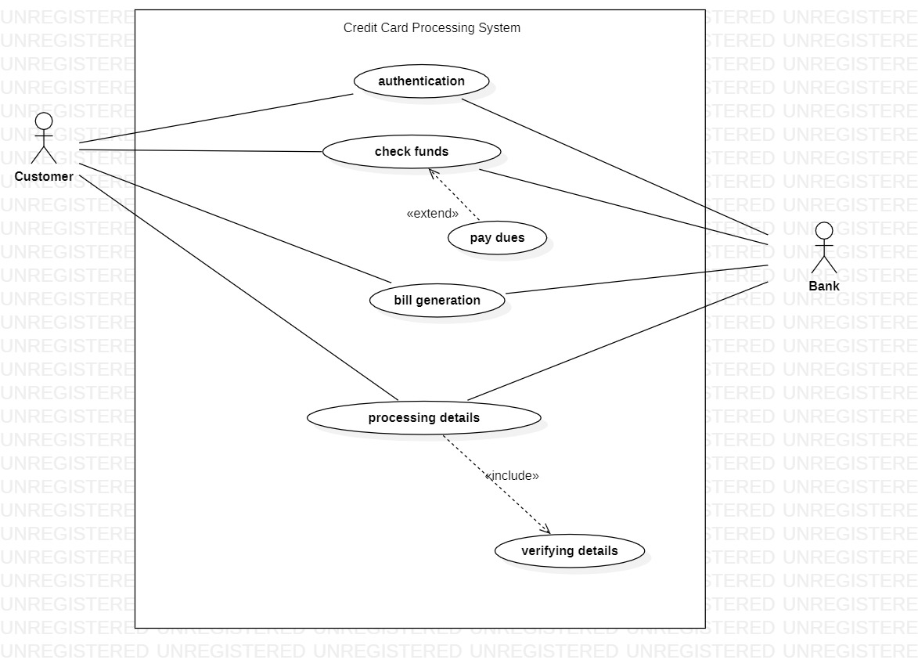

**Fig 2.3**

**Sequence Diagram**

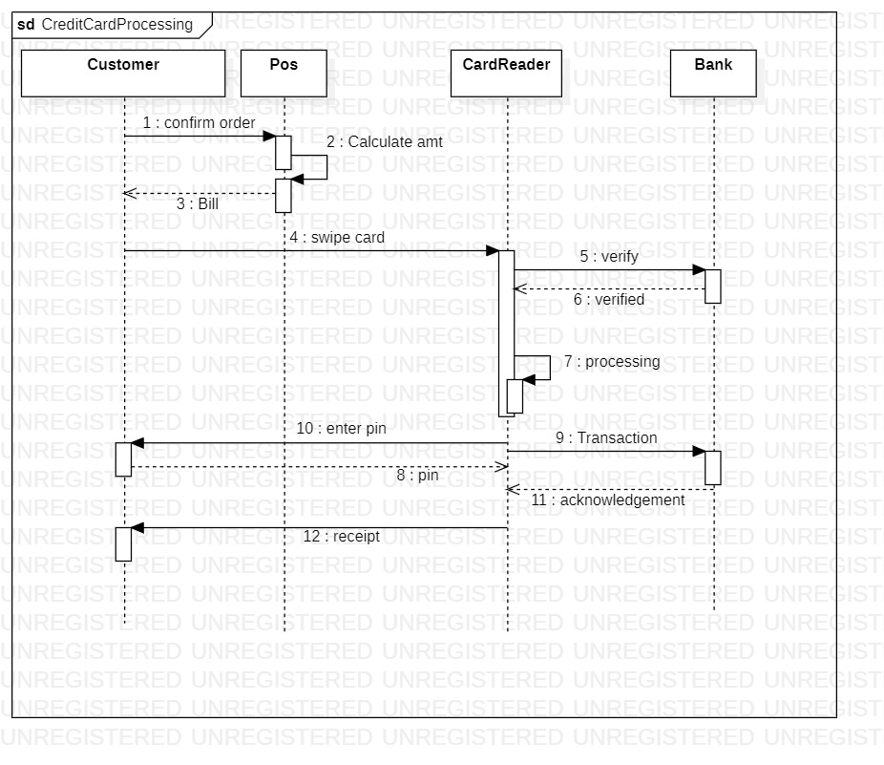

**Fig 2.4**

**Activity Diagram**

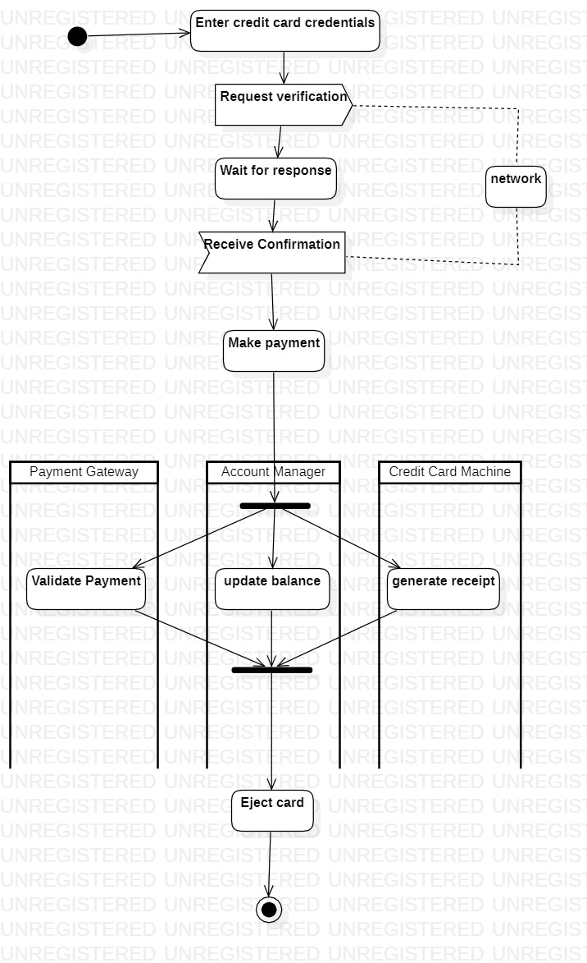

**Fig 2.5**

**Library Management System**

# **Problem Statement:**

To design a new and improved Library Management System for ABC College, it is necessary to address the shortcomings of the current system. The current system's inefficiency and lack of user-friendliness have resulted in manual management of collections and patron records, which is time-consuming and error-prone. The new system must improve the efficiency of library operations by automating the collection and patron record management, providing easy access to information, and streamlining administrative tasks. Additionally, it should provide better support for managing the collections, including advanced search capabilities and an intuitive user interface for browsing and reserving items. Ultimately, the new system must enhance the user experience for students and staff, making it easy to use and providing access to a vast collection of resources.

**Software Requirement Specification(SRS)**

**1 Introduction:**

**1.1 Purpose of this Document:**

The purpose of this SRS is to define the requirements for the development of a Library Management System. It provides a detailed description of the system and its features, along with the scope, constraints, and non-functional requirements.

**1.2 Scope of this Document:**

This document outlines the requirements for the Library Management System, which is a software application designed to manage the day-to-day operations of a library. The system is intended to provide a user-friendly interface for library staff to manage the library's resources, such as books, journals, and other materials, as well as to manage patron accounts and circulation of materials. The system will also include reporting capabilities to provide data analysis and decision support.

**1.3 Overview:**

The Library Management System is a web-based application that allows librarians to manage their library's resources and patrons. The system will include modules for managing books, journals, and other materials, as well as for managing patron accounts and circulation of materials. The system will be designed to be user-friendly and intuitive, with an emphasis on ease-of-use and efficiency.

**2 General Description:**

**2.1 Objective:**

The objective of the Library Management System is to provide a comprehensive tool for librarians to manage the library's resources and patrons. The system will be designed to streamline library operations and improve the overall efficiency of the library.

**2.2 User Characteristics:**

The system is intended for use by library staff, including librarians, library assistants, and other personnel. Users will be expected to have basic computer skills and knowledge of library operations.

**2.3 Features:**

The Library Management System will include the following features:

* Cataloging and classification of library materials
* Circulation of materials, including check-in/check-out and renewal
* Patron management, including registration, tracking, and notification
* Reporting and analysis of library data
* Integration with external databases and systems

**2.4 Benefits:**

The Library Management System will provide numerous benefits to the library, including:

* Improved efficiency and productivity of library staff
* Improved accuracy and reliability of library data
* Increased availability of library resources to patrons
* Enhanced patron experience and satisfaction

**2.5 User Community:**

The Library Management System is designed for use by libraries of all sizes and types, including public, academic, and special libraries. The system is intended to be scalable and flexible, allowing for customization to meet the unique needs of each library.

**3 Functional Requirements:**

**3.1 Cataloging and Classification:**

The system shall provide the ability to catalog and classify library materials, including books, journals, and other materials. Cataloging shall include data entry, editing, and deletion of bibliographic records.

**3.2 Circulation:**

The system shall provide the ability to circulate library materials, including check-in/check-out and renewal of materials. The system shall also provide notification of overdue materials and hold requests.

**3.3 Patron Management:**

The system shall provide the ability to manage patron accounts, including registration, tracking, and notification of account activity.

**3.4 Reporting and Analysis:**

The system shall provide the ability to generate reports and perform data analysis on library data, including circulation, cataloging, and patron activity.

**3.5 Integration:**

The system shall provide the ability to integrate with external databases and systems, including interlibrary loan systems and online databases.

**4 Interface Requirements:**

**4.1 User Interface:**

The user interface shall be designed to be user-friendly and intuitive, with an emphasis on ease-of-use and efficiency. The interface shall be web-based and accessible from any internet-connected device.

**4.2 System Interfaces:**

The system shall communicate with external databases and systems through APIs or other standard communication protocols.

**5 Performance Requirements:**

**5.1 Response Time:**

The system shall provide a response time of no more than 3 seconds for any user action.

**5.2 Capacity:**

The system shall be designed to handle a minimum of 500 simultaneous users.

**5.3 Data Storage:**

The system shall be able to handle a minimum of 100,000 bibliographic records and 50,000 patron records.

**5.4 Reliability:**

The system shall have a minimum uptime of 99.9% and shall be able to recover from any system failure within 15 minutes.

**6 Design Constraints:**

**6.1 Hardware:**

The system shall be designed to run on standard hardware configurations, including servers, workstations, and mobile devices.

**6.2 Software:**

The system shall be designed to run on standard software platforms, including web browsers and operating systems.

**6.3 Security:**

The system shall be designed to adhere to industry-standard security practices, including encryption of data and user authentication.

**7 Non-Functional Attributes:**

**7.1 Portability:**

The system shall be designed to be easily portable to different hardware and software platforms.

**7.2 Reusability:**

The system shall be designed to be easily reusable in other library settings.

**7.3 Application Compatibility:**

The system shall be designed to be compatible with other library applications and systems.

**7.4 Data Integrity:**

The system shall ensure the integrity and accuracy of all library data.

**7.5 Scalability:**

The system shall be designed to be scalable to meet the needs of libraries of all sizes.

**8 Preliminary Schedule and Budget:**

**8.1 Schedule:**

The development of the Library Management System is expected to take 12 months from the start of development to the final release.

**8.2 Budget:**

The estimated cost of development of the Library Management System is $150,000, including all hardware, software, and personnel costs.

**Class Diagram**

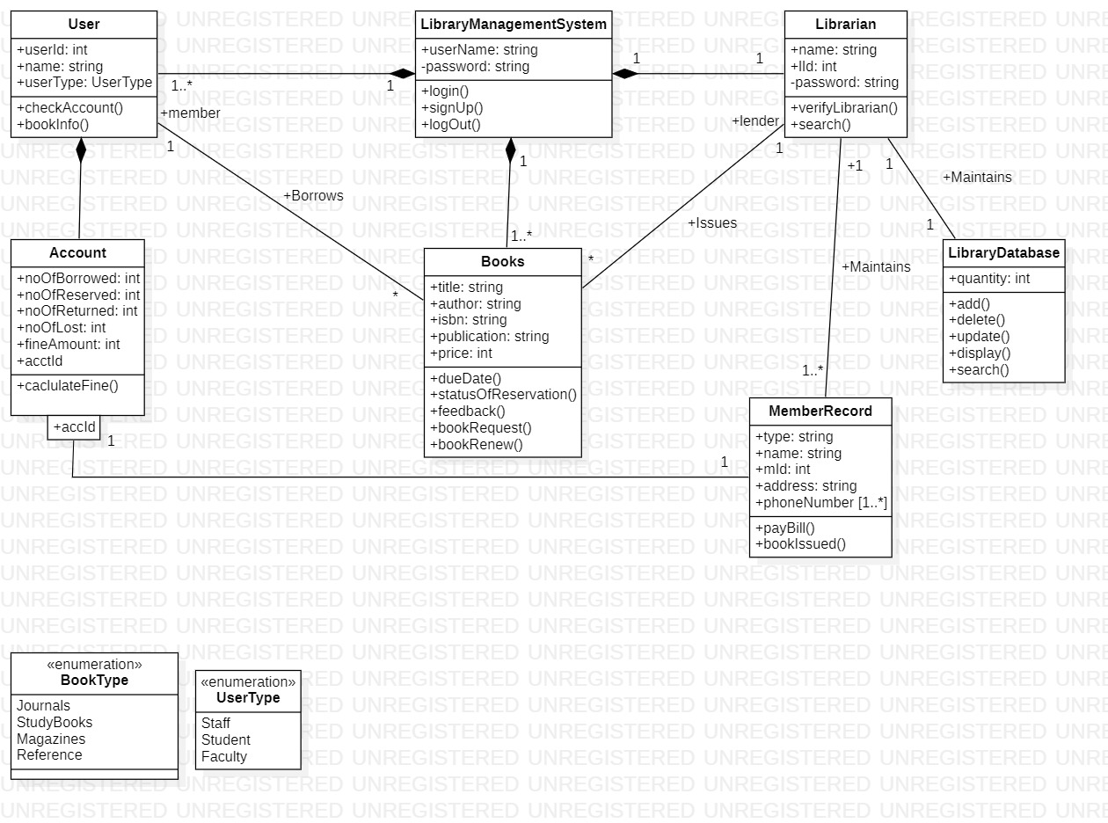

**Fig 3.1**

**State Diagram**

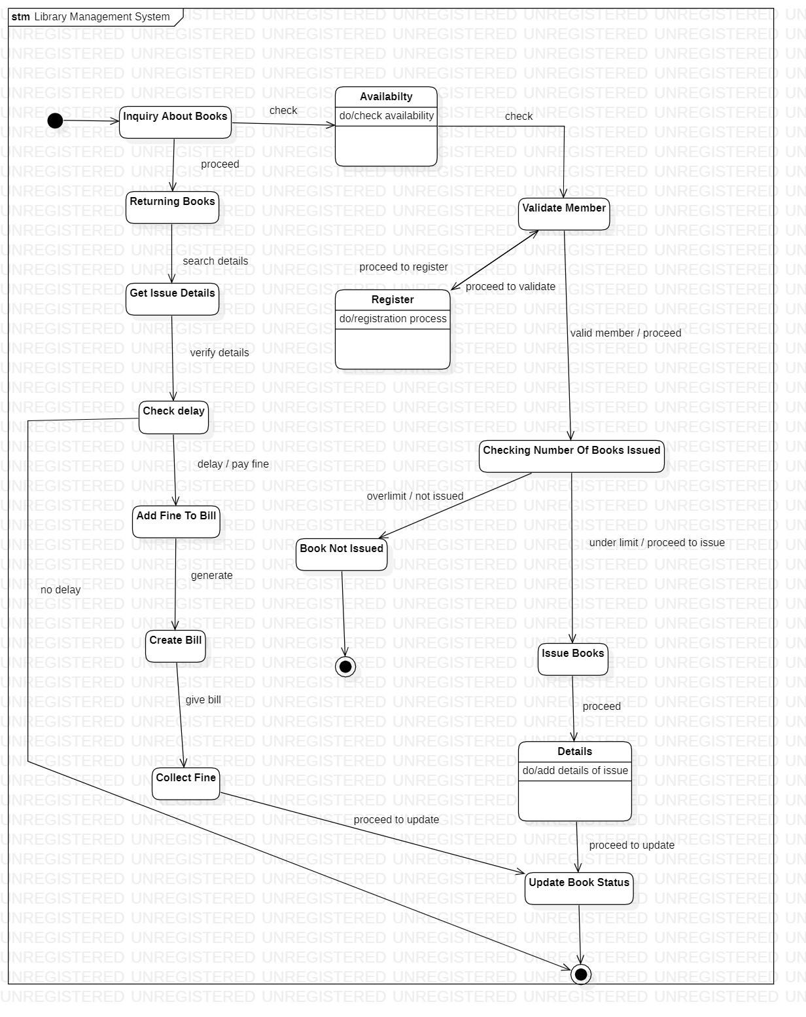

**Fig 3.2**

**Use Case Diagram**

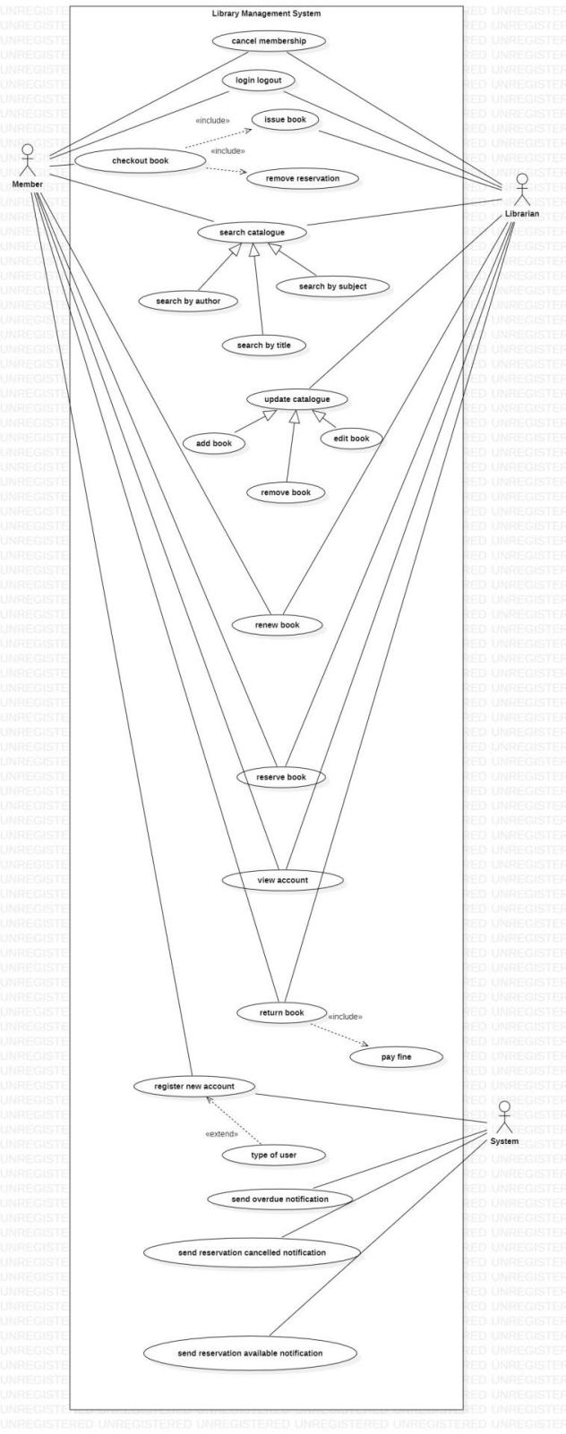

**Fig 3.3**

**Sequence Diagram**

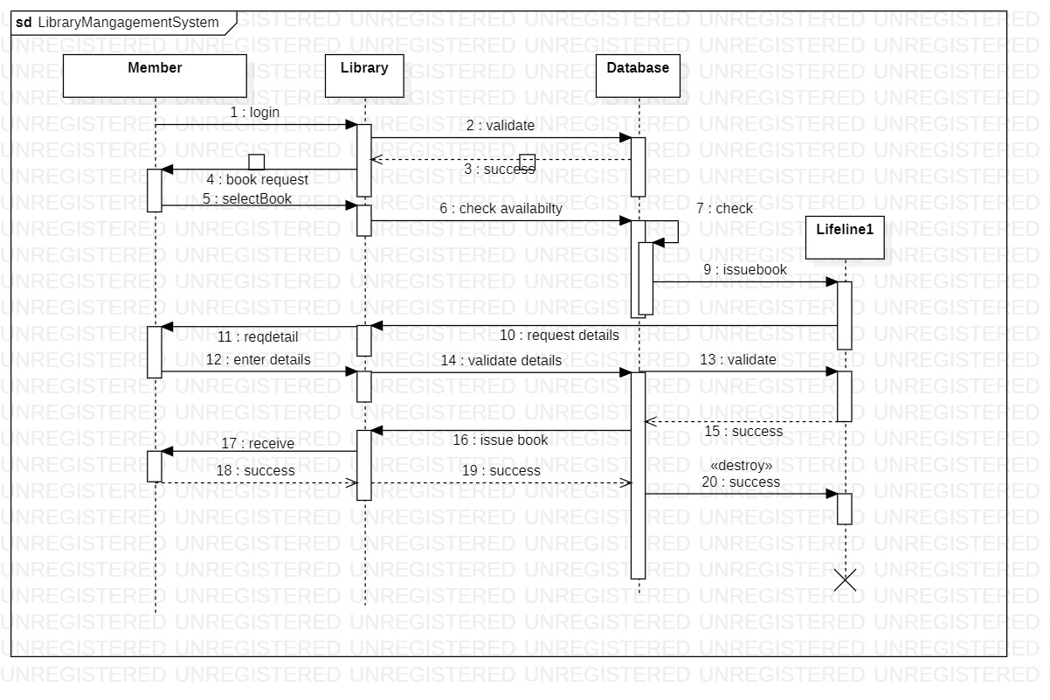

**Fig 3.4**

**Activity Diagram**

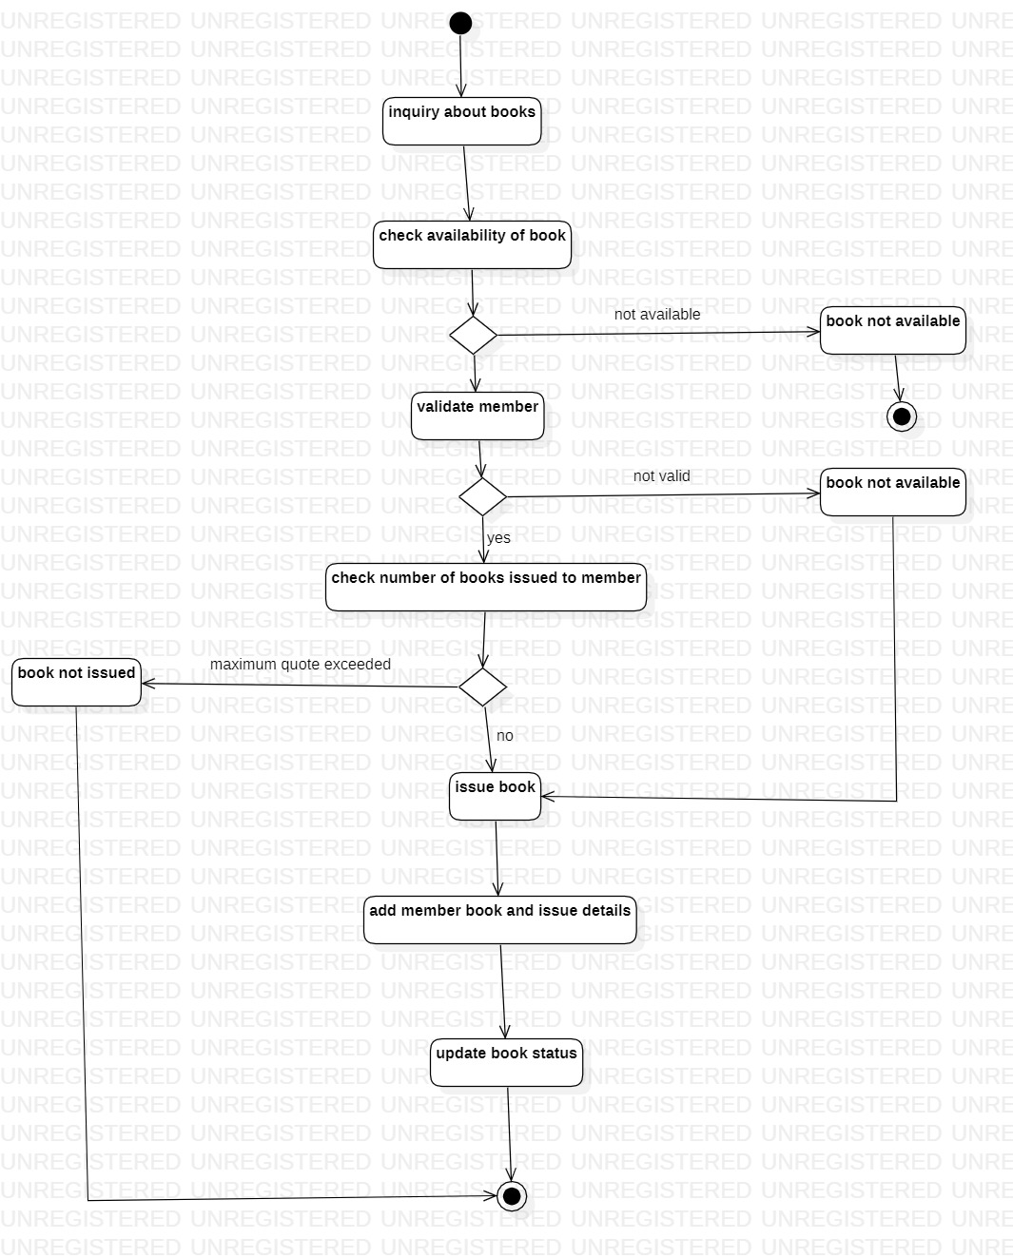

**Fig 3.5**

**Stock Maintenance System**

# **Problem Statement:**

To design a more efficient and effective stock management system, there is a need to address the challenges faced by businesses in managing their inventory. These challenges include inaccurate inventory tracking, inefficient order processing, and difficulties in forecasting demand. A new system is required that can improve inventory accuracy, streamline order processing, and provide better visibility into inventory levels and trends.

**Software Requirement Specification(SRS)**

**Introduction:**

**1.1 Purpose of this Document:**

The purpose of this document is to outline the functional and non-functional requirements for a Stock Management System to be developed for ABC Corporation.

**1.2 Scope of this document:**

This document describes the overall functionality of the Stock Management System and its features. It also includes the development cost and time required to develop the system.

**1.3 Overview:**

The Stock Management System is a software application designed to manage and track inventory levels, sales, and purchases of products. It will provide users with a user-friendly interface to manage stocks and generate reports.

**2 General Description:**

The Stock Management System will enable users to track inventory levels, sales, and purchases of products. The system will be able to provide real-time information on the stock levels, making it easier for users to manage their inventory. The system will be designed for businesses of all sizes and will provide features to manage multiple warehouses and product categories.

**3 Functional Requirements:**

The following are the functional requirements of the Stock Management System:

* Inventory Management: The system should be able to manage the inventory levels of products and provide real-time information on stock levels. Users should be able to add new products, update product information, and manage product categories.
* Sales Management: The system should be able to manage sales of products and provide reports on sales. Users should be able to create sales invoices, generate reports on sales, and view customer history.
* Purchase Management: The system should be able to manage purchases of products and provide reports on purchases. Users should be able to create purchase orders, generate reports on purchases, and view vendor history.
* Warehouse Management: The system should be able to manage multiple warehouses and transfer products between warehouses.
* Reporting: The system should be able to generate reports on inventory levels, sales, purchases, and other relevant metrics.

**4 Interface Requirements:**

The interface requirements for the Stock Management System include:

* User-friendly interface design
* Navigation and accessibility
* Data input and output
* Integration with other software and systems

**5 Performance Requirements:**

The performance requirements for the Stock Management System are as follows:

* Ability to handle large amounts of dat
* Real-time data access and reporting
* Quick report generation
* High availability and uptime

**6 Design Constraints:**

The design constraints for the Stock Management System are as follows:

* Scalability
* Security
* Ease of maintenance
* Use of industry-standard programming languages and frameworks

**7 Non-Functional Attributes:**

The non-functional attributes required by the Stock Management System are as follows:

* Security
* Portability
* Reliability
* Reusability
* Application compatibility
* Data integrity
* Scalability capacity

**8 Preliminary Schedule and Budget:**

This section outlines the initial version and budget of the project plan, including:

* Overall time duration required
* Overall cost required for development of the project.

**Class Diagram**

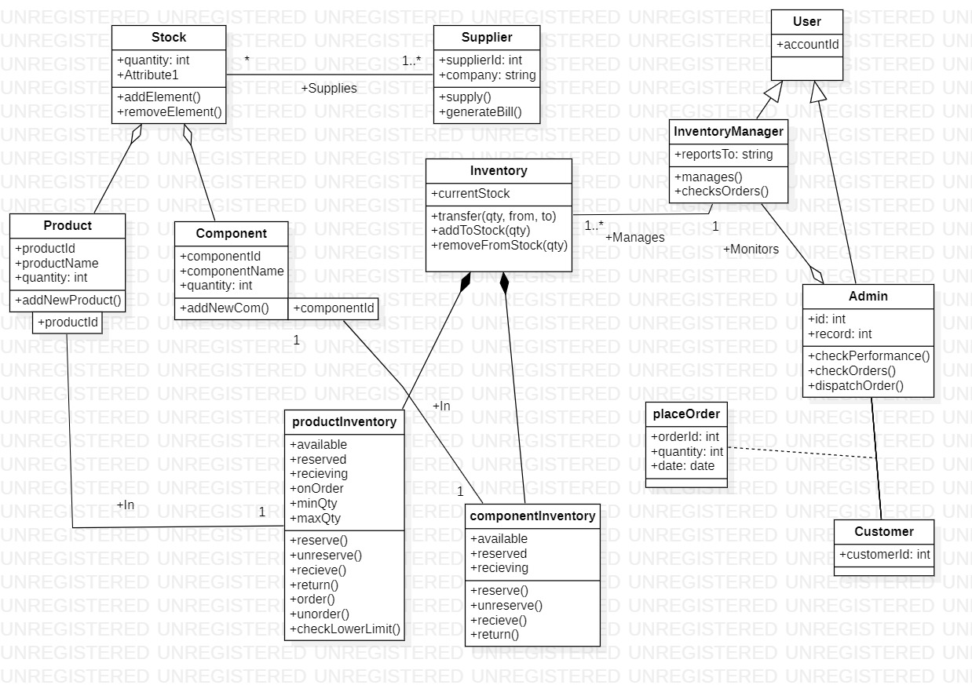

**Fig 4.1**

**State Diagram**

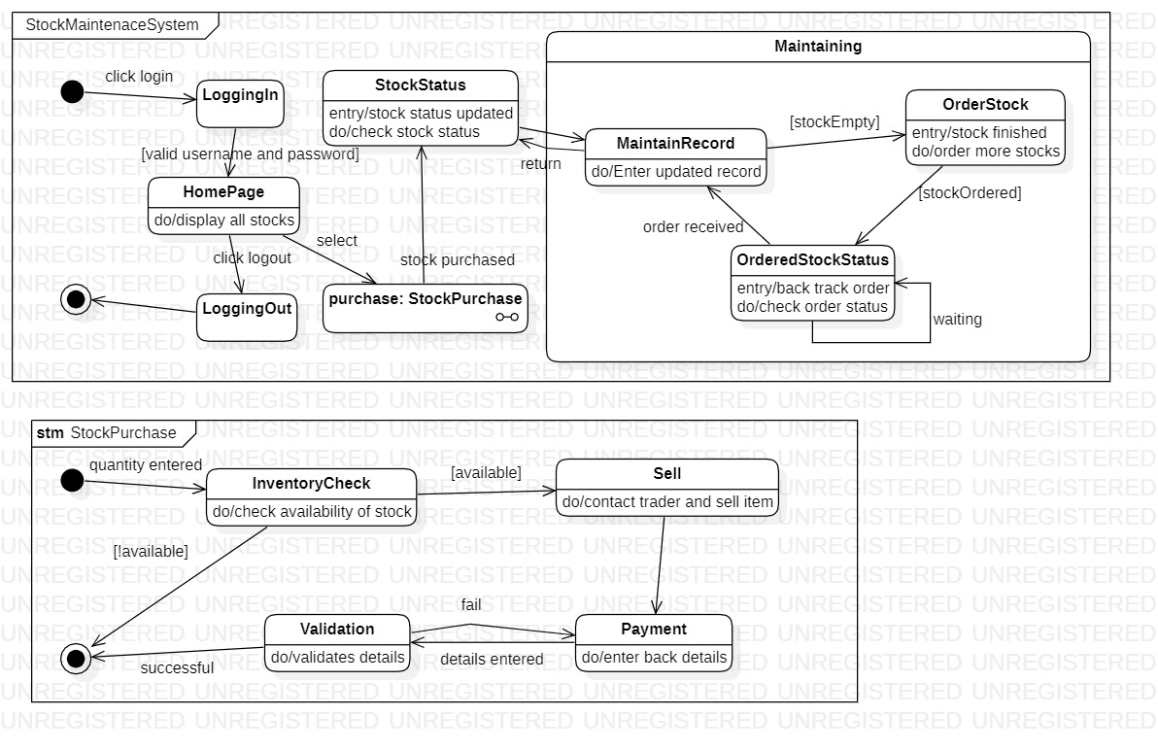

**Fig 4.2**

**Use Case Diagram**

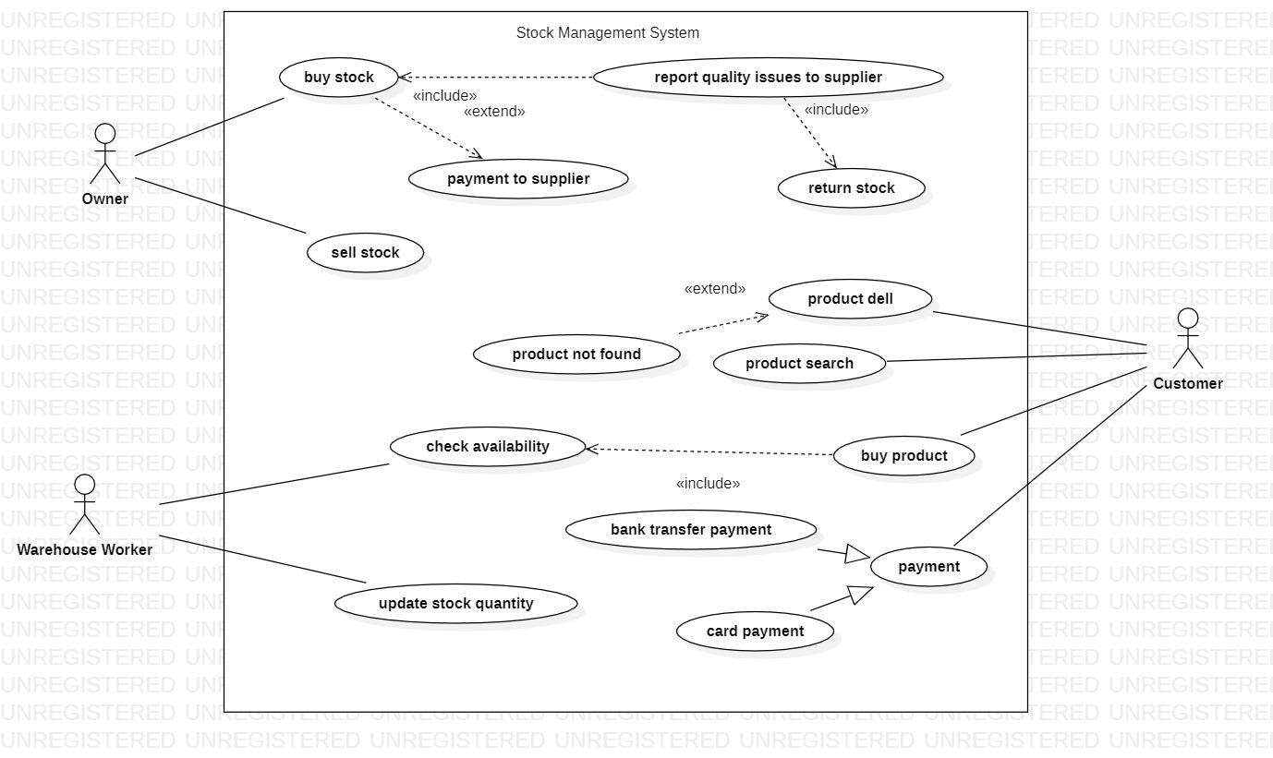

**Fig 4.3**

**Sequence Diagram**

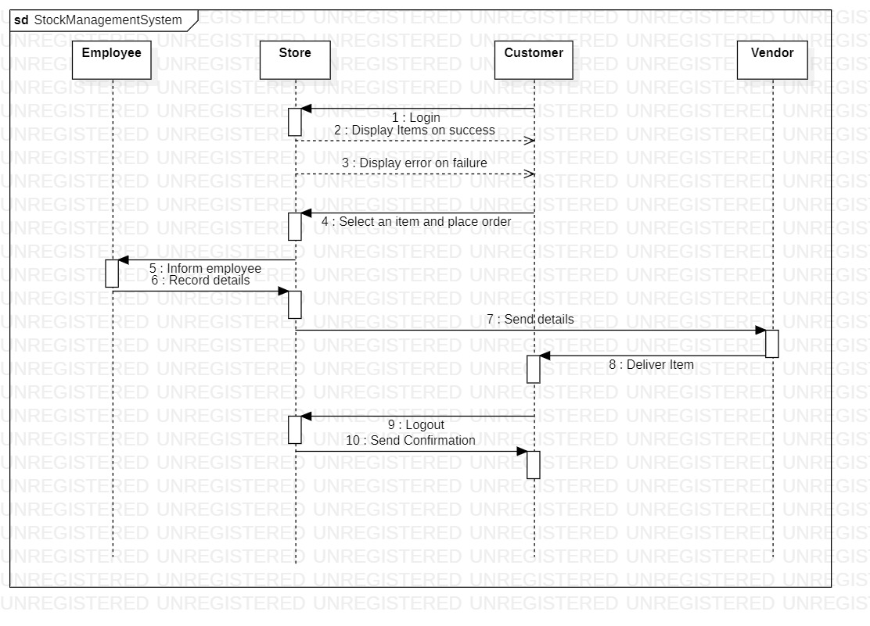

**Fig 4.4**

**Activity Diagram**

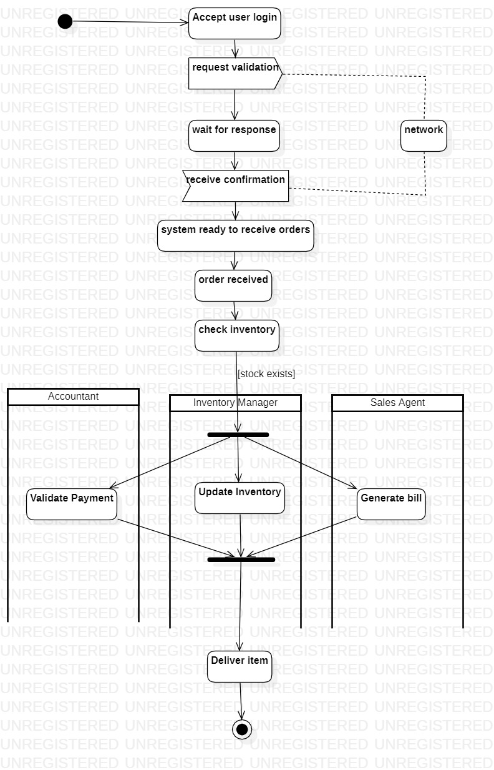

**Fig 4.1**

**Passport Automation System**

# **Problem Statement:**

To design an efficient and modern Passport Automation System that can handle the increasing demand for passport services and streamline the passport application and issuance process. The current manual process is time-consuming and prone to errors, leading to delays and inconvenience for passport applicants. There is a need for a system that can automate the entire process, from application submission to passport issuance, while ensuring the security and integrity of personal information.

**Software Requirement Specification(SRS)**

**1 Introduction:**

**1.1 Purpose of this Document:**

The purpose of this document is to provide a detailed description of the requirements for the development of a Passport Automation System. It specifies the functions, performance, design constraints, and interfaces of the system.

**1.2 Scope of this Document:**

This document provides a comprehensive description of the Passport Automation System. It includes the system's features, functions, and requirements necessary for its successful implementation. Additionally, it outlines the budget and time frame required for the development and implementation of the system.

**1.3 Overview:**

The Passport Automation System is designed to automate and simplify the passport application and issuance process. The system aims to provide a seamless and efficient process for passport applicants, including the ability to apply for a passport online, schedule an appointment, and track the status of their application. The system will also provide passport officers with a user-friendly interface for processing applications, managing records, and generating reports.

**2 General Description:**

**2.1 Objectives:**

The objective of the Passport Automation System is to streamline the passport application and issuance process, reduce processing times, and improve the overall experience for passport applicants and officers.

**2.2 Users:**

The users of the system will include passport applicants, passport officers, and system administrators.

**2.3 Features:**

The Passport Automation System will include the following features:

* Online passport application
* Appointment scheduling
* Application tracking
* Record management
* Report generation

**2.4 Benefits:**

The benefits of the Passport Automation System include improved efficiency, reduced processing times, improved accuracy, and enhanced customer satisfaction.

**2.5 User Community:**

The user community for the Passport Automation System includes passport applicants, passport officers, and system administrators.

**3 Functional Requirements:**

**3.1 Passport Application:**

The system should allow passport applicants to fill out and submit passport applications online. The application should include all necessary information, such as personal details and travel information.

**3.2 Appointment Scheduling:**

The system should allow applicants to schedule an appointment for submitting their application and completing the passport issuance process.

**3.3 Application Tracking:**

The system should allow applicants to track the status of their application and receive updates on its progress.

**3.4 Record Management:**

The system should allow passport officers to manage passport applications and records, including reviewing applications, verifying information, and issuing passports.

**3.5 Report Generation:**

The system should allow passport officers and system administrators to generate reports on passport applications, processing times, and other relevant data.

**4 Interface Requirements:**

**4.1 User Interface:**

The user interface of the system should be user-friendly, intuitive, and easy to navigate. It should include clear instructions and guidance for users.

**4.2 System Interfaces:**

The system should be able to interface with other systems as required, such as identity verification systems and payment gateways.

**5 Performance Requirements:**

**5.1 Speed:**

The system should be able to process passport applications quickly and efficiently, with minimal waiting times for applicants.

**5.2 Scalability:**

The system should be designed to handle large volumes of passport applications and be scalable as the number of applications grows.

**6 Design Constraints:**

**6.1 Security:**

The system should be designed to be secure, with appropriate measures in place to protect user data and prevent unauthorized access.

**6.2 Technology Constraints:**

The system should be developed using industry-standard programming languages and frameworks, and be compatible with modern web browsers and mobile devices.

**7 Non-Functional Attributes:**

**7.1 Reliability:**

The system should be reliable and available at all times, with minimal downtime or disruption.

**7.2 Usability:**

The system should be designed to be user-friendly and intuitive, with clear instructions and guidance for users.

**7.3 Accessibility:**

The system should be accessible to all users, including those with disabilities or limited technology access.

**8 Preliminary Schedule and Budget:**

**8.1 Development Timeframe:**

The development of the Passport Automation System is expected to take approximately 12 months.

**8.2 Development Budget:**

The development budget for the Passport Automation System is estimated to be $1,000,000.

**Class Diagram**

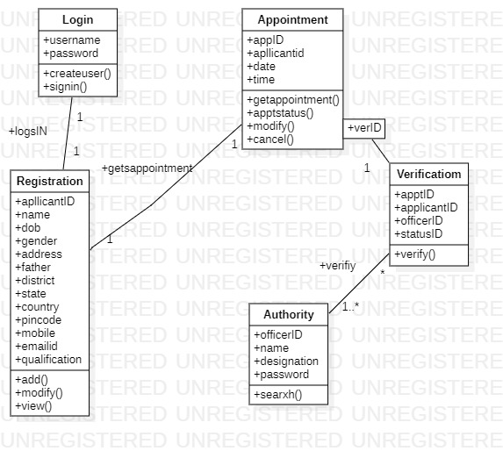

**Fig 5.1**

**State Diagram**

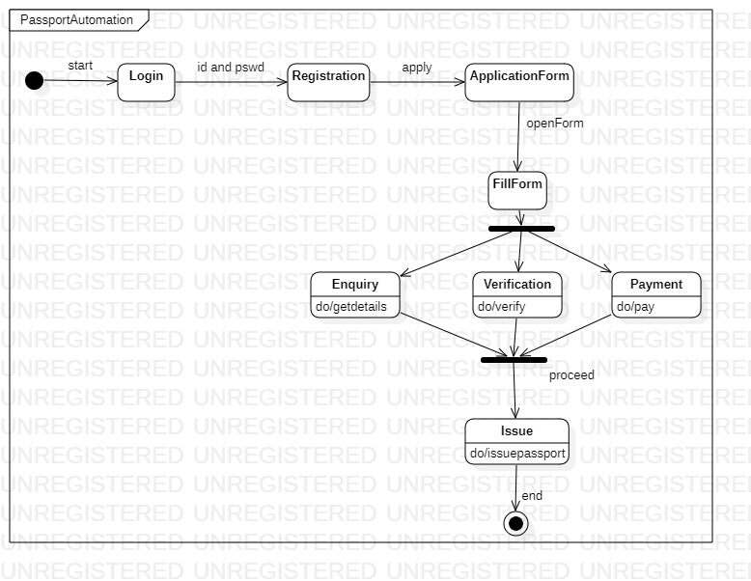

**Fig 5.2**

**Use Case Diagram**

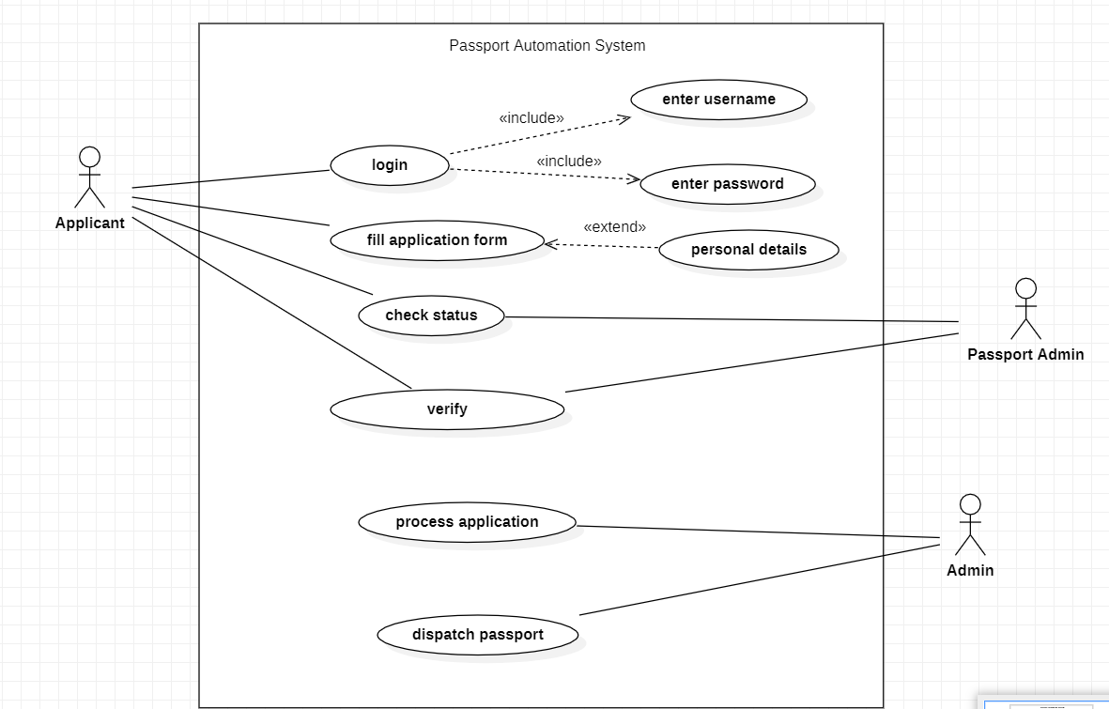

**Fig 5.3**

**Sequence Diagram**

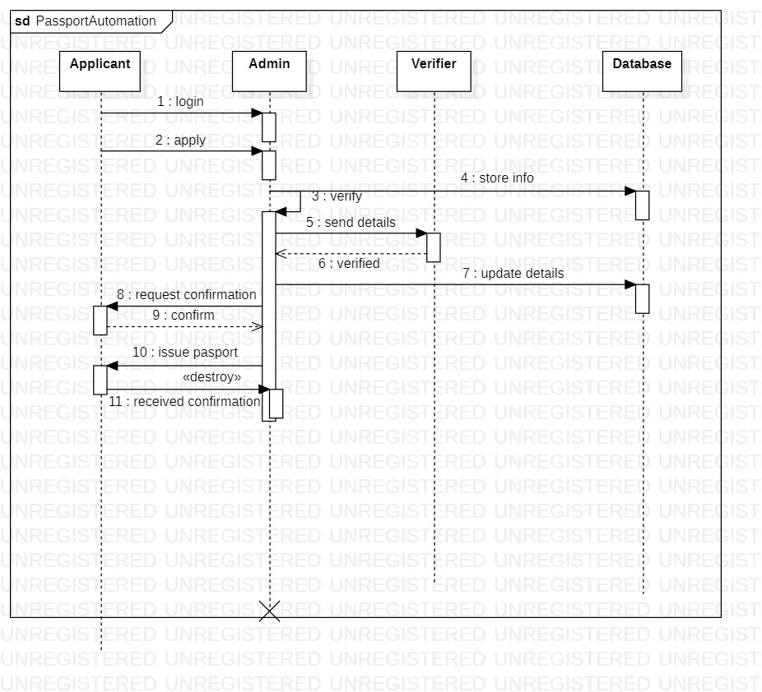

**Fig 5.4**

**Activity Diagram**

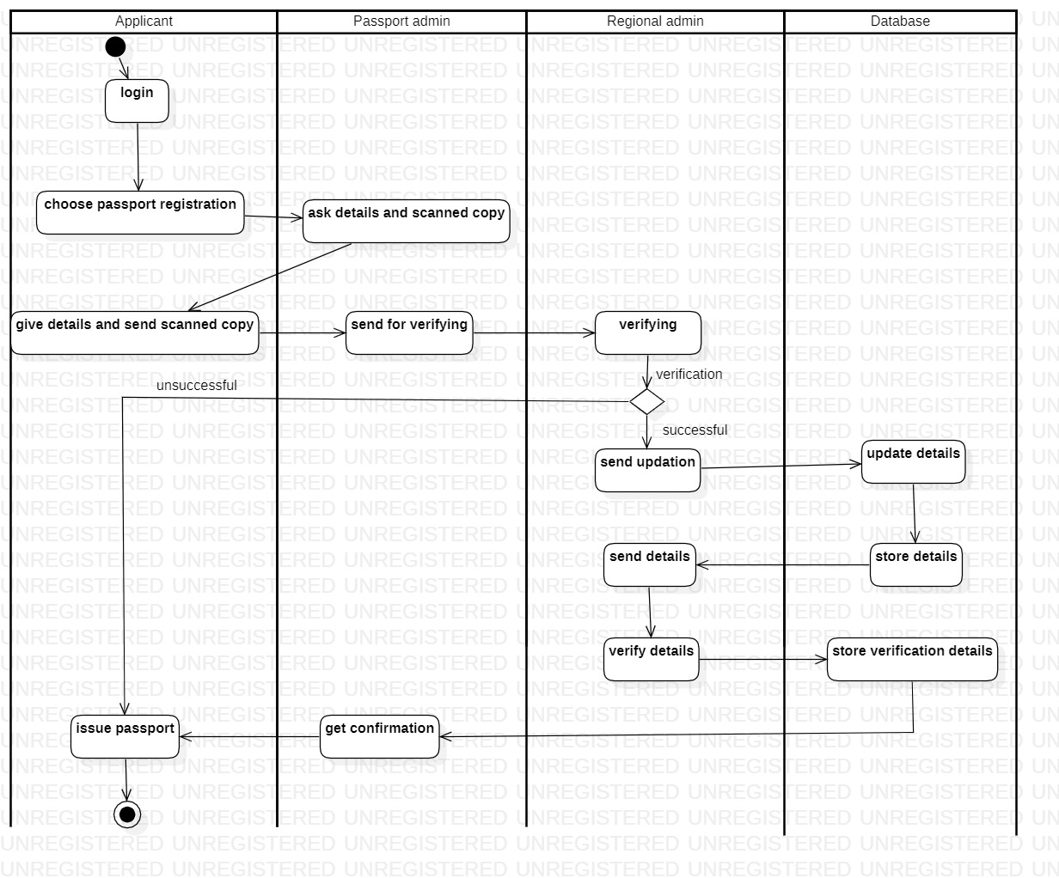

**Fig 5.5**

**Railway Reservation System**

# **Problem Statement:**

To design a modernized and efficient Railway Reservation System that can simplify the ticket booking process, provide real-time information on train schedules and seat availability, and enhance the overall customer experience. The current system is outdated, slow, and does not offer online booking options, which leads to long queues and inconvenience for passengers. Therefore, there is a need for a new system that leverages technology to streamline the ticket booking process, offer online booking options, and provide passengers with real-time updates on train schedules and seat availability.

**Software Requirement Specification(SRS)**

**1 Introduction**

**1.1 Purpose of this Document**

The purpose of this document is to provide a detailed description of the Railway Reservation System. It outlines the requirements, functionalities, and constraints of the system.

**1.2 Scope of this Document**

This document covers the requirements for the Railway Reservation System, which includes booking and canceling train tickets, managing train schedules, and generating reports.

**1.3 Overview**

The Railway Reservation System is an online application designed to simplify the process of booking train tickets. It allows users to search for trains, view schedules, book and cancel tickets, and generate reports. The system is intended to provide a user-friendly interface that is easy to navigate.

**General Description**

**2.1 Product Functions**

The Railway Reservation System allows users to perform the following functions:

* Search for trains based on origin, destination, and date of travel
* View train schedules, availability of seats, and fare information
* Book and cancel train tickets
* Generate reports on train schedules, bookings, and cancellations

**2.2 User Characteristics**

The Railway Reservation System is intended for use by passengers who wish to book train tickets. It is also designed for use by railway staff who manage train schedules and ticketing operations.

**2.3 Features**

The Railway Reservation System includes the following features:

* User authentication and authorization
* Search functionality for train schedules and availability of seats
* Secure payment gateway for online transactions
* Integration with external systems for train schedules and fare information
* Real-time updates on train schedules and ticket availability
* Reporting functionality for train schedules, bookings, and cancellations

**2.4 Benefits**

The Railway Reservation System offers the following benefits:

* Simplified booking process for train tickets
* Faster and more efficient management of train schedules and ticketing operations
* Improved customer experience with real-time updates and secure online transactions

**2.5 User Community**

The Railway Reservation System is designed for use by passengers who wish to book train tickets, as well as railway staff who manage train schedules and ticketing operations.

**3 Functional Requirements**

The Railway Reservation System must fulfill the following functional requirements:

* User Registration and Login: The system must allow users to create a new account and login with their credentials. The user registration process must include basic information such as name, email address, and contact details.
* Train Search and Booking: The system must allow users to search for trains based on their source and destination stations, date of travel, and class of travel. The system must display the available trains and their schedules along with the ticket fare. The user must be able to select the desired train, class, and seat, and proceed with the booking.
* Ticket Cancellation and Refund: The system must allow users to cancel their booked tickets and receive a refund based on the cancellation policy. The user must be able to view the cancellation charges and refund amount before confirming the cancellation. The canceled seats must be made available for booking by other users.

**4 Interface Requirements**

The Railway Reservation System should have a user-friendly interface that is easy to navigate. It should include the following interfaces:

* User login interface for authentication and authorization
* Search interface for train schedules and availability of seats
* Payment gateway interface for online transactions
* Reporting interface for train schedules, bookings, and cancellations

**5 Performance Requirements**

The Railway Reservation System must meet the following performance requirements:

* The system should be able to handle a large number of concurrent users
* The system should provide real-time updates on train schedules and ticket availability
* The system should generate reports quickly and efficiently
* The system should be available 24/7 with minimal downtime

**6 Design Constraints**

The Railway Reservation System must meet the following design constraints:

* The system must be scalable and easy to maintain
* The system should be developed using industry-standard programming languages and frameworks
* The system should be secure and protect personal information
* The system should be compliant with relevant data protection regulations

**7 Non-Functional Attributes:**

**7.1 Security:**

The Railway Reservation System should be designed with high-security standards to protect user data and prevent unauthorized access. The system should include secure authentication and encryption protocols for communication between the user and the system.

**7.2 Portability:**

The Railway Reservation System should be designed to be portable, allowing users to access it from various platforms and devices, such as desktop computers, laptops, tablets, and smartphones. The system should be compatible with popular operating systems like Windows, macOS, Linux, iOS, and Android.

**7.3 Reliability:**

The Railway Reservation System should be highly reliable, with minimal downtime and disruptions. The system should be designed to handle high volumes of traffic and user requests without crashing or slowing down.

**7.4 Reusability:**

The Railway Reservation System should be designed with reusable components and modules to enable future upgrades and maintenance. The system should be modular, allowing developers to modify or add features without affecting the system's overall functionality.

**7.5 Application Compatibility:**

The Railway Reservation System should be compatible with various third-party applications, such as payment gateways, messaging services, and social media platforms. The system should be designed to seamlessly integrate with these applications, ensuring smooth and uninterrupted user experience.

**7.6 Data Integrity:**

The Railway Reservation System should ensure the integrity and accuracy of user data. The system should include measures to prevent data loss or corruption, such as regular backups and data validation checks.

**7.7 Scalability Capacity:**

The Railway Reservation System should be scalable to accommodate future growth and expansion. The system should be designed to handle an increasing number of users and transactions without affecting its performance or functionality.

**8 Preliminary Schedule and Budget:**

The development of the Railway Reservation System is expected to take approximately 12 months. The project team will consist of five developers, two quality assurance testers, and one project manager. The estimated budget for the project is $500,000, including development costs, hardware, and software expenses, and project management fees. The project will follow an agile methodology with regular sprints and milestones to ensure timely delivery and quality assurance.

**Class Diagram**

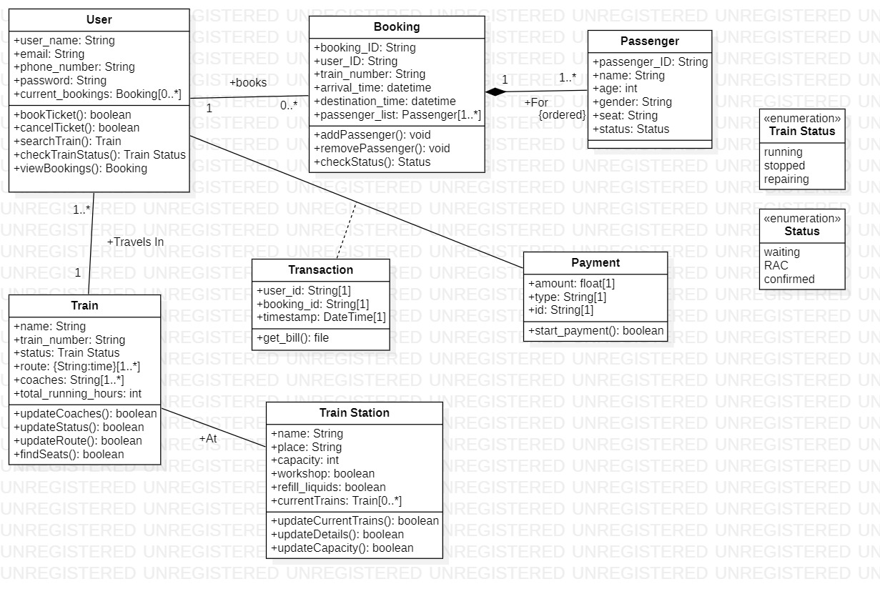

**Fig 6.1**

**State Diagram**

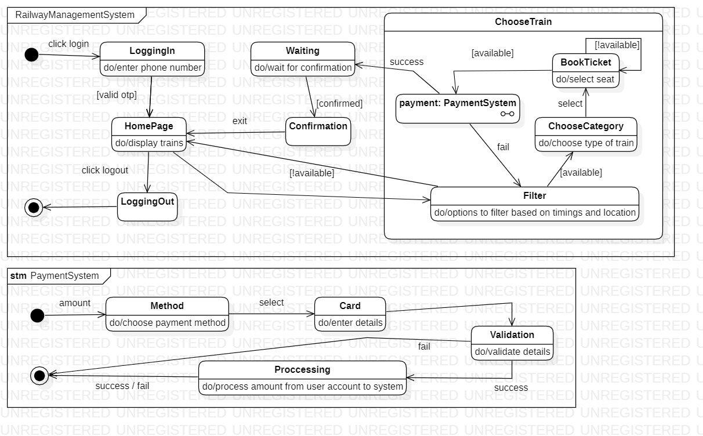

**Fig 6.2**

**Use Case Diagram**

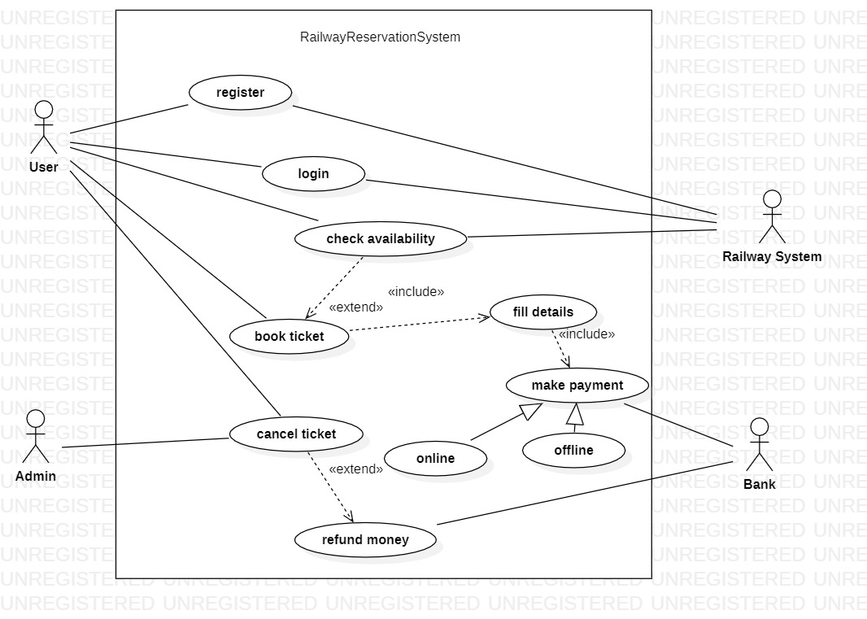

**Fig 6.3**

**Sequence Diagram**

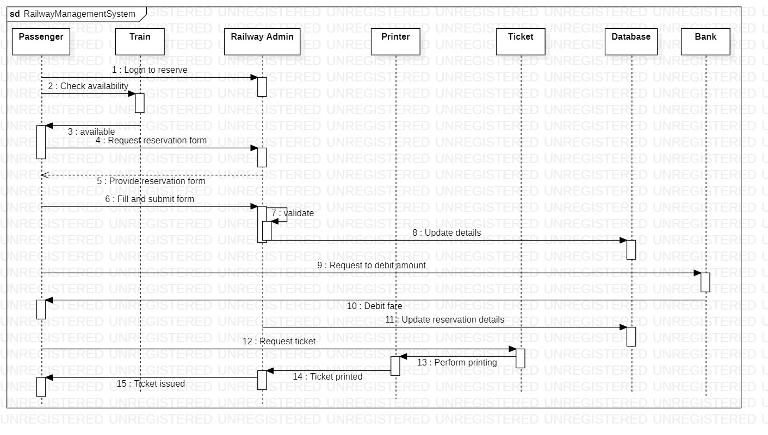

**Fig 6.4**

**Activity Diagram**

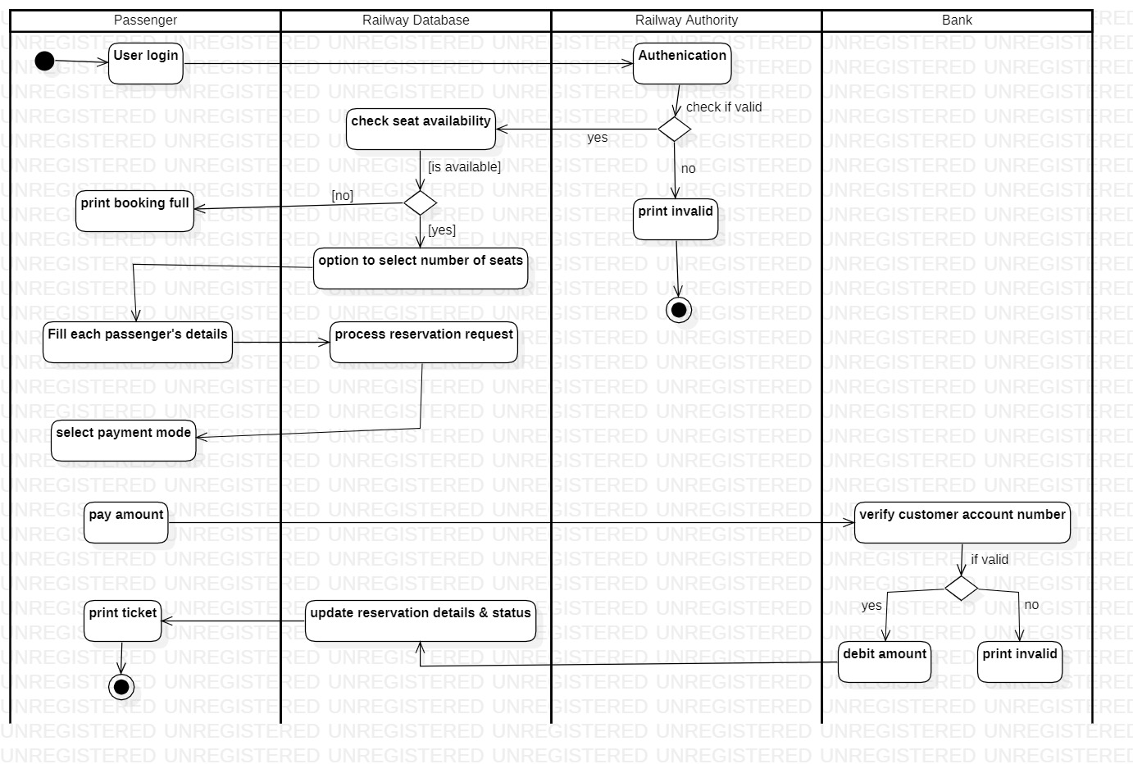

**Fig 6.5**

**Online Shopping System**

# **Problem Statement:**

To design an effective and efficient Online Shopping System that meets the requirements of customers, it is necessary to ensure that the system has strong security measures, is easy to use and navigate, is highly reliable, has excellent performance, and is scalable to accommodate future growth and increased demand. The system should be developed within the allocated budget and schedule and should address any additional costs or changes to the project scope in a timely and effective manner.

**Software Requirement Specification(SRS)**

**1 Introduction**

**1.1 Purpose of this Document**

 The purpose of this document is to provide a detailed description of the requirements for the Online Shopping System. It outlines the goals and objectives of the system, the scope of the project, and the key features and functionality that the system will provide.

**1.2 Scope of this Document**

This document will serve as the basis for the development of the Online Shopping System. It will guide the development team and serve as a reference point throughout the development process.

**1.3 Overview**

The Online Shopping System is an e-commerce platform that allows users to browse and purchase products online. It will provide a user-friendly interface that allows customers to easily find and purchase products, as well as manage their accounts and track their orders.

**2 General Description**

**2.1 Product Perspective:**

The Online Shopping System will be an independent system that will interface with various payment gateways and shipping providers. It will also provide integration with social media platforms to enable customers to share their shopping experiences with their friends and followers.

**2.2 Product Functions:**

The system will allow users to browse products by category, search for specific products, add items to a shopping cart, and complete a checkout process. Customers will be able to manage their accounts, view their order history, and track their orders.

**2.3 User Characteristics:**

The Online Shopping System will be designed for a wide range of users, including individuals, small businesses, and large corporations. Users will require basic computer literacy skills to use the system.

**2.4 Constraints:**

The system must comply with all relevant laws and regulations related to e-commerce, including data privacy and security regulations.

**3 Functional Requirements**

**3.1 Product Features:**

* User Registration: Customers can create an account to save their personal information and order history.
* Product Search: Customers can search for products by name, category, or brand.
* Product Catalog: Customers can browse products by category and view product details, including images and pricing.
* Shopping Cart: Customers can add products to their cart and manage the quantities of each item.
* Checkout Process: Customers can complete the checkout process by entering their shipping and payment information.
* Order Tracking: Customers can track the status of their orders and view order history.

**4 Interface Requirements**

**4.1 User Interface:**

The user interface will be designed to be user-friendly and intuitive, with clear navigation and prominent calls to action.

**4.2 Hardware Interfaces:**

The system will require a computer or mobile device with an internet connection.

**4.3 Software Interfaces:**

The system will interface with various payment gateways and shipping providers to process payments and manage shipping.

**5 Performance Requirements**

**5.1 Response Time:**

The system should respond to user actions quickly, with a maximum response time of 2 seconds.

**5.2 Concurrent Users:**

The system should be able to handle a large number of concurrent users, with a minimum of 1000 users at any given time.

**5.3 Availability:**

The system should be available 24/7, with a maximum downtime of 1 hour per month.

**6 Design Constraints**

**6.1 Hardware Limitations:**

The system should be designed to run on standard hardware and should not require any specialized equipment.

**6.2 Security:**

The system must be designed to be secure, with measures in place to protect user data and prevent unauthorized access.

**6.3 Scalability:**

The system should be designed to be scalable, with the ability to handle increased traffic and user demand.

**7 Non-Functional Attributes**

**7.1 Security:**

The Online Shopping System should have strong security measures to protect customer data and prevent unauthorized access. The system should use encryption and secure protocols for all data transmission and storage.

**7.2 Usability:**

The Online Shopping System should be easy to use and navigate, with an intuitive user interface. The system should also provide clear and concise product descriptions and pricing information to help users make informed decisions.

**7.3 Reliability:**

The Online Shopping System should be highly reliable, with minimal downtime and maximum availability. The system should have backup and recovery mechanisms in place to ensure that data is not lost in case of a system failure.

**7.4 Performance:**

The Online Shopping System should be designed to handle a large number of users and transactions simultaneously. The system should also have fast response times and provide real-time updates on order status and inventory levels.

**7.5 Scalability:**

The Online Shopping System should be scalable to accommodate future growth and increased demand. The system should be able to handle a growing number of users and transactions without compromising performance or functionality.

**8 Preliminary schedule and budget:**

* Project duration: 6 months
* Team size: 5 developers
* Budget: $200,000 (Development costs: $150,000, Hardware expenses: $20,000, Software expenses: $30,000)
* Phases: Requirements gathering and analysis (2 weeks), Design and architecture (4 weeks), Development and testing (12 weeks), Deployment and maintenance (8 weeks)
* Additional costs or changes to the project scope will be communicated to stakeholders and addressed accordingly.

**Class Diagram**

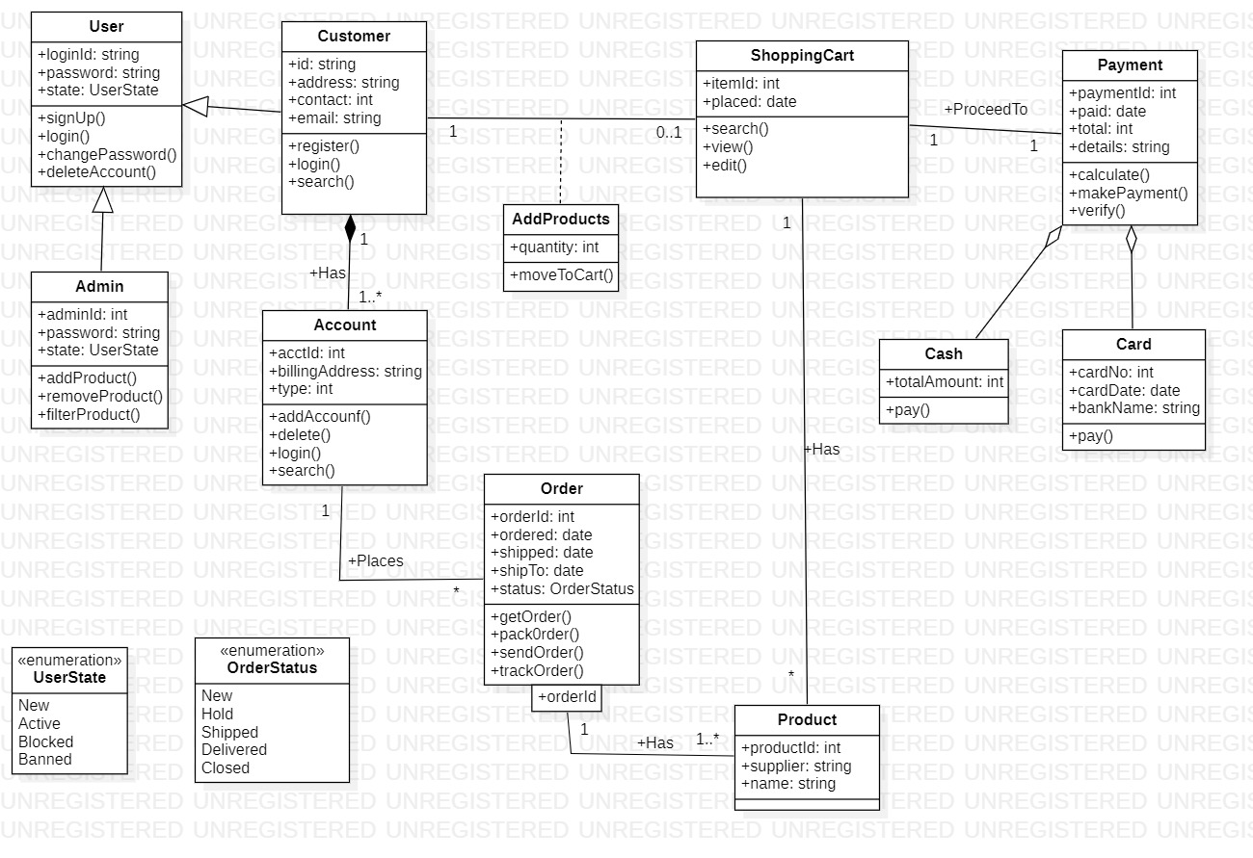

**Fig 7.1**

**State Diagram**

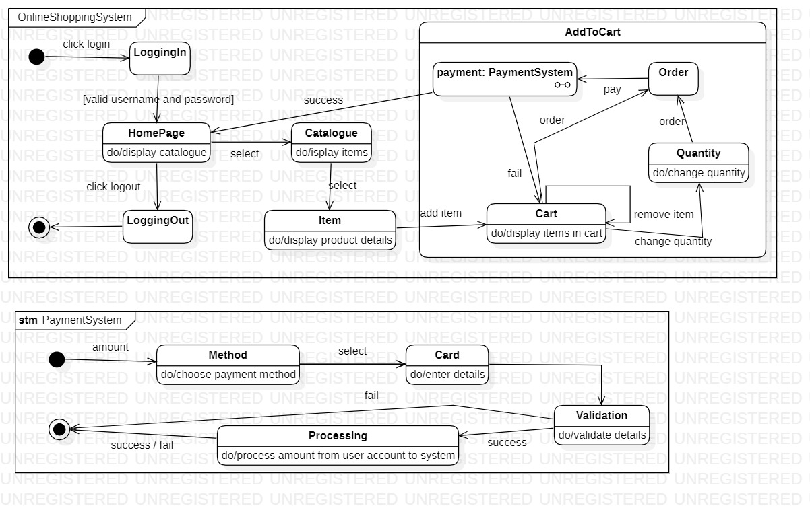

**Fig 7.2**

**Use Case Diagram**

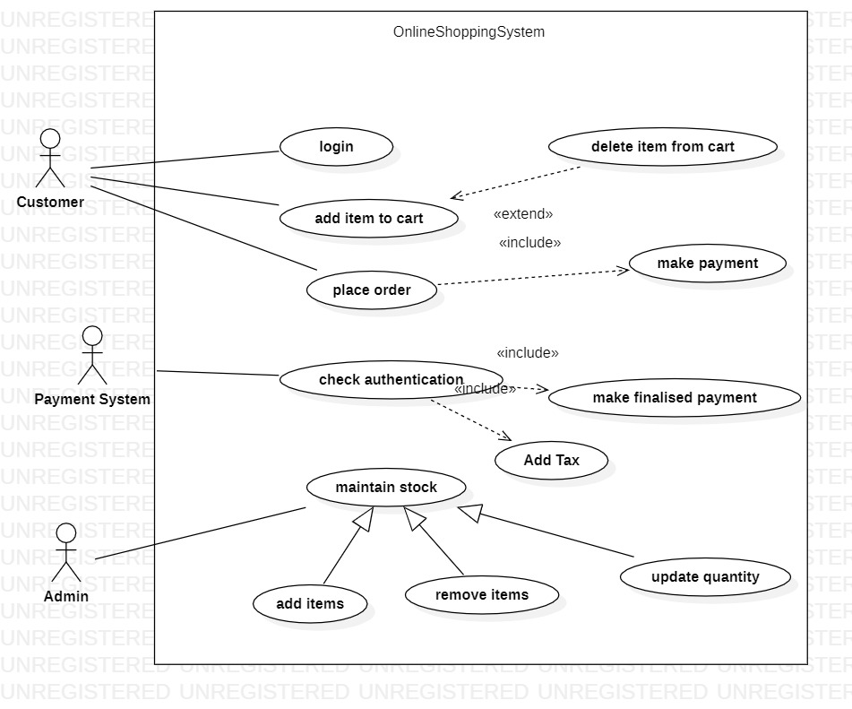

**Fig 7.3**

**Sequence Diagram**

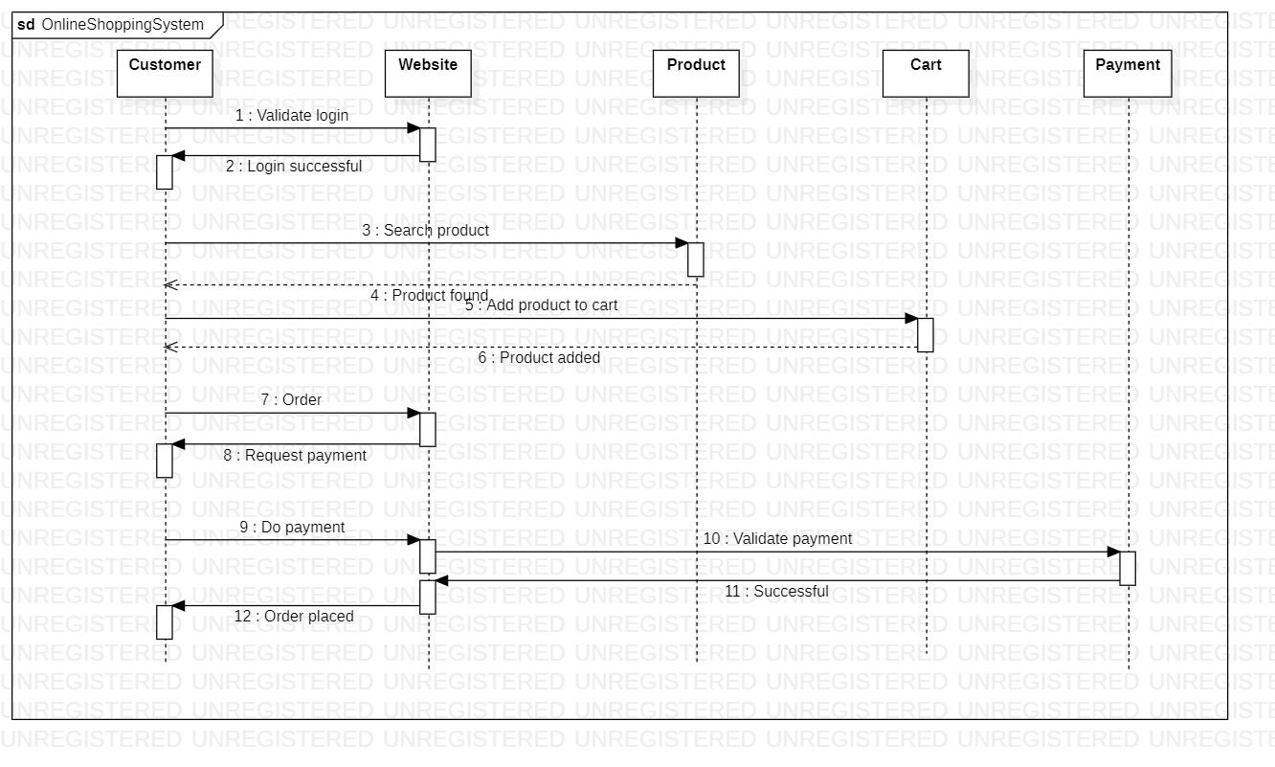

**Fig 7.4**

**Activity Diagram**

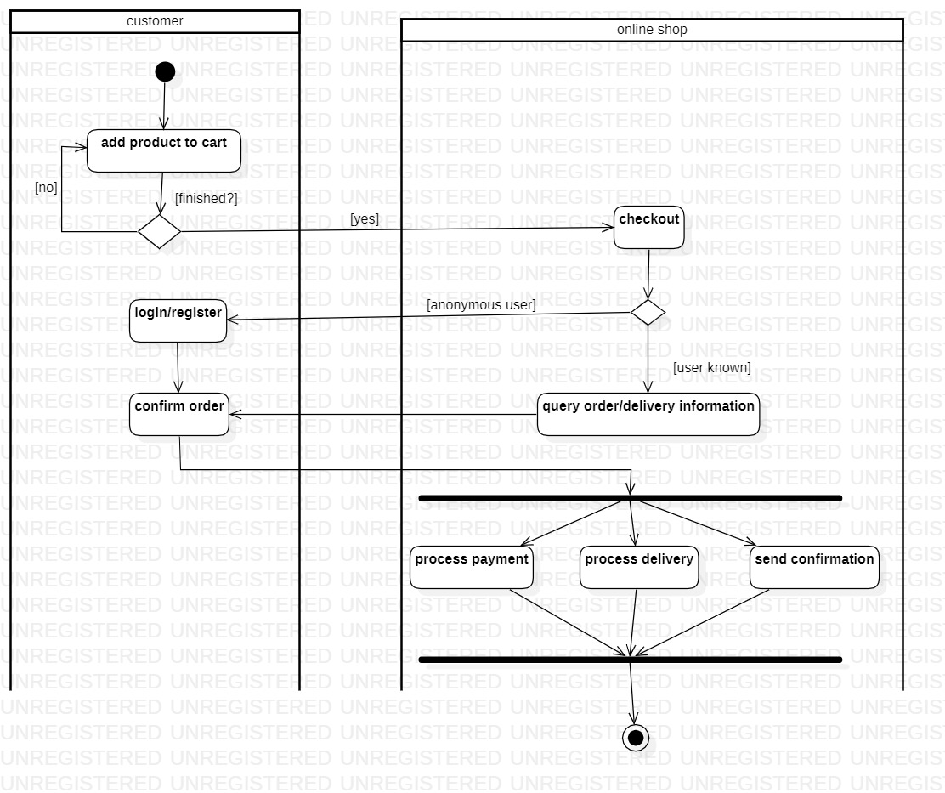

**Fig 7.5**